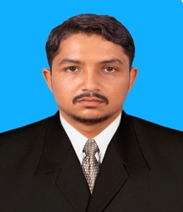

Curriculum Vitae

**Contact: +92-303-5732869**

**Address: Near Hussain Floor Mill Nai Abadi Mohallah Makhdoom Abad Jada Jhelum**

**Email Address:** [**mwaqas869@yahoo.com**](mailto:mwaqas869@yahoo.com)

**Personal Detail**

* + **Name Muhammad Waqas Kashif**
  + **Father ’ Name Abdul Haq**
  + **NIC 37301-6566732-9**
  + **D.O.B 27-Dec-1998**
  + **Gender Male**
  + **Religion Islam**
  + **Marital Status Un-Married**
  + **Nationality Pakistani**
  + **Domicile Jhelum (Punjab)**

**Qualification**

**Objective**

|  |  |  |  |  |
| --- | --- | --- | --- | --- |
| **Degree** | **Department** | **Board/University** | **Year** | **Marks** |
| S.S.C | Science | BISE Rawalpindi | 2011-13 | 712/1050 |
| D.A.E | Mechanical | PBTE Lahore | 2013-16 | 2740/3450 |

* If you give me a chance to work .I want to make you assure to win your confidence through my hard work, honesty And devotion, to work as I know that in “hard work” is Key to success.

**Certificate / Diploma**

* Certificate in Auto CAD (2D+3D)

**Self Skills**

* Hard Worker
* Punctual
* Self Motivated

**Reference**

* Reference Will Be Furnished on Demand.