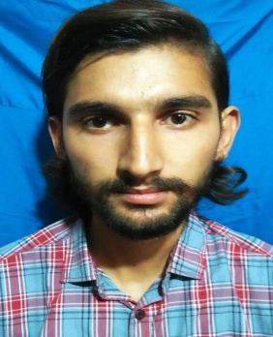 ***WAHEED SHAHZAD***

|  |  |
| --- | --- |
| **Objective** | Seeking a challenging job in an Organization where, I can enhance my Professional skills, Knowledge and Contribute to overall its success. |

|  |
| --- |
|  |

|  |  |
| --- | --- |
| **Address:** | House # 8, St # 1, Mohallah RehmanPura, Okara. |

|  |  |
| --- | --- |
| **Personal Information** | * **Father's Name:** : Maqsood Ahmad * **Date of Birth:** : 06-05-1994 * **Cnic No.:** : 35302-9929192-3 * **Domicile**: : Okara (Punjab) * **Religion**: : Islam * **Marital Status:** : Single * **Mobile No.** : 0304-6080781 * **Nationality:**  : Pakistani |
|  |  |

|  |
| --- |
| **Academic Qualification:** |

|  |  |  |  |
| --- | --- | --- | --- |
| **DEGREE** | **BOARD / UNIVERSITY** | **YEARS** | **MARKS** |
| Matric | BISE Lahore | 2011 | 714/1050 |
| F.S.C | BISE Sahiwal | 2013 | 742/1100 |
| BSCS (Hons) | GCUF Sahiwal Campus | 2014-2018 | 3.68 CGPA |

|  |  |
| --- | --- |
| **EXPERT IN:** | 1. AutoCAD (2d) 2. Web Designing(Front-end developer) 3. Visual Basic 4. M S Office (Word, Access, PowerPoint etc.) 5. Basic Networking Knowledge. |
| **Experience** | 3 Year work in Bhatti IT Solution as a computer Operator.  4 Month Computer Diploma in AutoCAD & MS Office. |

|  |  |
| --- | --- |
| **Reference:** | Will be availing on demand. |