**Curriculum Vitae**

**OBJECTIVE**

To serve my skills in a well renowned organization and reach the peak of management hierarchy by my creative efforts

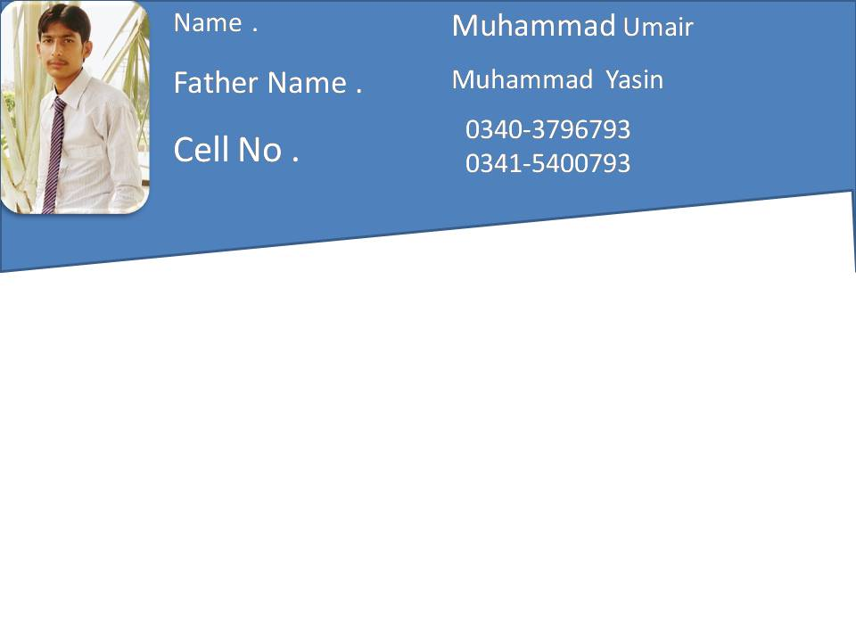

* CNIC # : 33104-4815505-9
* Domicile : Faisalabad ( Punjab )
* Date of Birth : 15/09/1996
* Nationality : Pakistani
* Marital Status : Single
* Language : Urdu, English, Punjabi.
* Religion : Islam
* Address : Chak No 93 R.B Chitti Teh. Jaranwala Dist. Fsd

**Qualification**

|  |  |  |  |  |  |
| --- | --- | --- | --- | --- | --- |
| **Description** | **Major subjects** | **Obtained marks/ Total marks** | **Session** | **Board** | **Division** |
| Matriculation | Science | 697/1050 | 2012/2013 | Lahore | 1st |
| 3 Year DAE | Electrical | 2471/3550 | 2013/2016 | TEVTA | 1st |

***Experience*** 1.Year 3.Month

Recently Working in Sitara Coal Fire Power Plant 40MW As a (Assistant CRO) (Lockal & Hollysys Macs DCS) Control Operating System > Steam Turbine (505 Governor) Control Condensing and Extraction,

11kv Generator (Jinan Power China)

The Plant Having high Pressure Boiler Coal Based 150T/h 99 Bar Pressure Temperature 535°C

Comprehensive Knowledge of Electrical System Synchronizaton, Generator Protections, LT HT Breakers.

Have a Good Knowledge About The Operation of Power House Auxliliaries

Ability to Respond Quickly and Multi-task efficiently.

Synchronizaton with Grid Load Sharing

**COMPUTER KNOWLEDGE**

* MS Office (Word, Excel, PowerPoint)
* Windows XP and other software installation
* Internet setup & Use.

**Hobbies**

* Sports
* Reading Books
* Movies

**Reference:**

* Reference will be provided on demand.