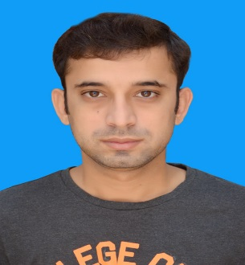

DOB 26 -10 -1992

Internee Engineer

Internee Engineer

Trainee Engineer

Feb 2012 - Feb 2016

2008 - 2010

2007 - 2008

**Languages:**

ENGLISH, URDU

**Engr. Muhammad Hasaan**

**(BS Chemical Engineer)**

**PERSONAL STATEMENT**

Flate-No.110 Central Flate Kotha-Pind Faisal Town Lahore, Punjab Pakistan.

Cell: +923016844623, +923326844007 Email: [hasaanhamed@gmail.com](mailto:hasaanhamed@gmail.com) engr.hasaan92@outlook.com

LinkedIn: <https://www.linkedin.com/in/muhammad-hasaan-70837487/>

FB: <https://web.facebook.com/hasaan.pk> Twitter: <https://twitter.com/Hasaan623>

Skype: Muhammad.hasaan92

**WORK EXPERIENCE**



* Finial Year Project: Ethanol Production from waste paper through fermentation process by utilizing yeast.
* Internship: Two weeks Internship in PARCO in Utility Area. Qasba-Gurat (Pakistan Largest Refinery).
* Two month as Chemical Engineer (Internee Chemist) in Process area and Lab work in Al-Moiz Sugar Industry Dera Ismail Khan. (KPK)
* One year Al-Ghazi Tractor Limited (Paint Shop Production Department and laboratory Supervisor) as Trainee Engineer Dera Ghazi Khan Plant.

** EDUCATION**

* BS Chemical Engineering (BUITEMS)
* FSC MATH (Abdalian Higher Secondary School) BISE D-G-K.
* Matric (Bio) BISE D-G-Khan.

**Skills**

* Hysys
* MS Word
* Power point
* Windows