***CURRICULUM VITAE***

**CURRECULUM VITAE**

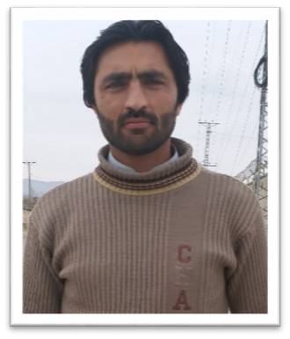

***Personal Details***

|  |  |  |  |
| --- | --- | --- | --- |
| *Name* | *Sher Nawaz* | *B/Group* | *O-* |
| *F/Name* | *Ayub Khan* | *Gender* | *Male* |
| *Date of birth* | *06-03-1995* | *Language known* | *English, Urdu, Pashto* |
| *Marital Status* | *Married* | *Email* | *Shernawaz477@yahoo.com* |
| *Nationality* | *Pakistani* | *cellphone* | *0345-8842357* |
| *Present Address* | *Village Mardan khel P/o Teri Teh Banda Daud Shah Distt Karak* | | |
| *Permanent Address* | *As above* | | |

***Educational Qualification***

|  |  |  |  |  |  |  |
| --- | --- | --- | --- | --- | --- | --- |
| *Name of Examination* | *Year of Passing* | *Group* | *GPA/Marks* | *Percentage* | *Grade* | *Board/*  *University* |
| *S.S.C* | *2011* | *Science* | *784* | *73%* | *A* | *BISE Kohat* |
| *H.S.S.C* | *2013* | *Science* | *812* | *74%* | *A* | *BISE Kohat* |
| *Bachelor*  *(16 years)* | *2017* | *Bs Electrical Engineering* | *3.65* | *91%* | *A* | *BUITEMS*  *Quetta* |

* Carreer Objectives

To work with maximum potential in a challenging and dynamic environment, with an opportunity of working with diverse group of people and enhancing my professional skills

with learning and experience for career growth.

* Technical Skills

MS-Word, Power Point, Excel, Window 7 and XP, Internet Ability.Installation of new electrical components or maintenance and repair of existing electrical infrastructure.

* ***Personal Qualities***

Positive attitude towards work and great ability towards result oriented output. Excellent Communication/inter personal skills to interact with individuals at all levels.

|  |  |
| --- | --- |
| * *Key Strengths*   *Daring to dream big and work on that instantly. Challenge seeker, enthusiastic and optimistic. Smart worker and good grasping power.* | * *Main Subjects*   *Power Generation, Power Distribution*  *Power Utilization, Power transmission, Power system Protection, Advance Electrical Machines, PLCID* |