**Ahmad Umair Abbasi**

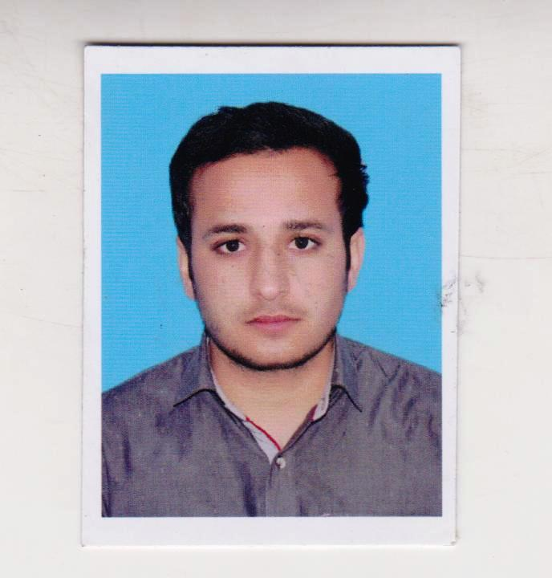

|  |  |
| --- | --- |
| **Bahria University**  **Islamabad Campus**  **Email:** [umairabbasi9537@gmail.com](mailto:umairabbasi9537@gmail.com)  **Mobile:** +92 3055600284 |  |

|  |  |  |
| --- | --- | --- |
| **Objective:** To work in a challenging environment to polish my skills in the field and to implement the knowledge which I got during my studies. | | |
| **Education** | | |
| **2014-2018**  **2011-2013**  **2009-2011** | **BE Electrical (Electronics) Engineering, Bahria University Islamabad Campus, Islamabad**  CGPA - 3.13/4.00  **HSSC Government post graduate college Vehari, Vehari**  798/1100  **SSC Bilal higher secondary school(boys) Vehari, Vehari**  789/1050 | |
| **Experience** | | |
| **July 2017 to August 2017**  **June 2018**  **to till now** | Internship at Andromeda technologies Pvt. Ltd.  Worked with client of Andromeda technologies Pvt. Ltd. “M/S Huawei technologies Pakistan private limited in north region”.    Working with Wi-tribe Pakistan as executive field support. | |
| **Final Year Project** | | |
| **CAN bus for vehicles:** Making control area network (CAN) bus for vehicles for serial data communication between different nodes of vehicle. | | |
| **Semester Projects** | | |
| • automatic parking system  • control of lamp by sound | | |
| **Honors & Achievements** | | |
| **Achievements**  **Computer Skills**  **Personnel interest** | | Got laptop in PM laptop scheme 5nd semester.  MS Word, MS Excel, MATLAB, Auto CAD, Keil u Vision,  PSpice, C++, PLC’s, Verilog  Sports, E-gaming, Traveling and exploring new things |