**Muhammad Bilal Nazeer**

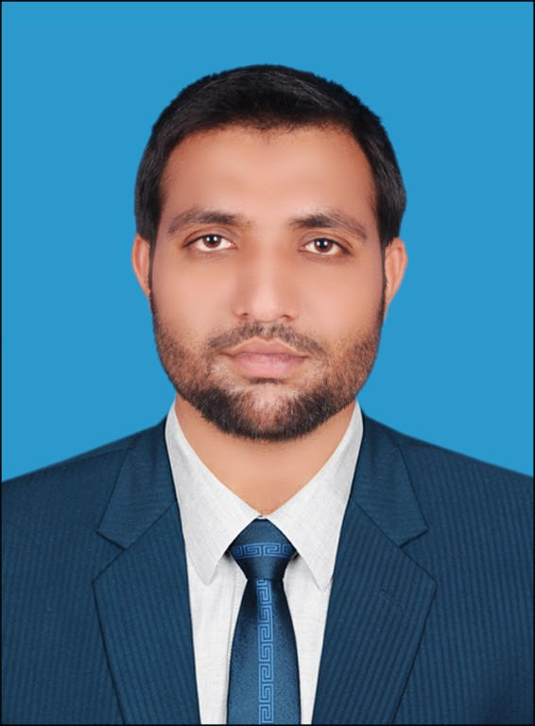

**Mechanical Engineer**bilalnazir689@gmail.com  
0332-1678433, 0302-6858427

**PEC Registration No. 34617**

**Personal Information’s**

Name Muhammad Bilal Nazeer

Father’s Name Nazeer Ahmad

Date of Birth 05-10-1993

Nationality Pakistani

Passport Number FY9829211

Religion Islam

Marital Status Single

CNIC No 33203-4192921-1

Mobile No +92-332-1678-433

**Career Objective**

Seeking a challenging career in the field of Mechanical Engineering within a dynamic and

Progressive environment where there is a maximum chance of learning expertise.

**Academic Qualification**

|  |  |  |  |  |
| --- | --- | --- | --- | --- |
| **Degree** | **Institute** | **Subject** | **Year** | **%age** |
| Metric (Science) | BISE Faisalabad | Science | 2007-2009 | 86.76% |
| F. Sc. (Pre-Engineering) | BISE Faisalabad | Science | 2009-2011 | 79.63% |
| B.Sc (Mechanical Engineering) | UCE&T B.Z.U Multan | Engineering | 2011-2015 | 73.46%  CGP=3.61 |

**Professional Qualification**

1. Course Name:**Performing Authority**

Certification from Dolphin Energy Ltd. Qatar

1. Course Name:**Confined Space Entry**

Certified by Enertech Qatar (Security No.532302179295)

1. Course Name: **H2S/BA (QP APPROVED)**

Certified by Enertech Qatar (Security No.10102179032)

1. Course Name: **FIRE/HOLE WATCH TRAINING**

Certified by Enertech Qatar (Security No.5410217A0424)

**Professional Experience of (2) Years**

Supervisor/PTW Coordinator

Dolphin Energy Ltd. Qatar | Descon Engineering Qatar L.L.C

23.02.2017 ----- 30.03.2017

* Carryout Maintenance of Heat Exchanger
* Carryout visual Inspection of Equipment’s
* Carryout visual Inspection of fittings
* Carryout Mechanical Isolation
* Carryout Shell and Tube side Hydro jetting
* Bundle Tube Hydro testing
* Final visual inspection of all shutdown equipment’s with third party representatives.

Supervisor /Mechanical Lead Worker

Qatar Chemicals Ltd. Qatar | Descon Engineering Qatar L.L.C

22.12.2016 ----- 23.02.2017

* Turbine rotor Replacement, maintenance and Alignment.
* Bearing Replacement of Turbine.
* Carryout visual Inspection of turbine parts.
* Bellow and damper replacement of Flare.
* Maintenance of Heat Exchanger.
* Cleaning and visual Inspection of heat Exchanger Tubes.
* Inspection of Bearing & shaft.
* Final visual inspection of all shutdown equipment’s
* Full cooperation with third party inspection representatives.

Trainee Mechanical Engineer

Star Engineering Kinetics | 1230 MW Power Project Haveli Bahadur Shah,Jhang

14.08.2016 ----- 20.12.2016

Worked on behalf of Star Engineering Kinetics as Trainee Mechanical Engineer in fabrication division & Fields

* Fabrication of CW pipeline
* Supervision of Manpower at workshops & fields and prepare the progress sheets as per clients requirements.

Internee

Pakistan Ordinance Factory | Wah Cantt.

15.08.2014 ----- 11.09.2014

* CNC and manual Lath &Milling Machine operations
* Metal cutting operation
* Welding operations
* Assembly Line
* Fabrication

Internee

Thermal Power Station | Muzaffar Garh, Multan

26.06.2013 ----- 25.07.2013

* Boilers
* Pumps
* Working of Steam Turbines
* Fabrication of spools
* Welding & Dimension Inspection
* Visual Inspection of parts

**Final Year Project**

Design of an escalator

(Automatic Moving Staircase)

**Computer Skills**

* Ms Office
* Internet Activities

**Basics of…..**

* AutoCAD (2D-Design)
* Pro. E/Solid Work (3D-Design)
* MATLAB

**Languages**

* Urdu
* English
* Punjabi

**Contact Details**

Chak No. 20 Ghagh Tehsil Shorkot Distt. Jhang, P/O Shorkot City. Province Punjab, Pakistan

Cell # +92-332-1678-433

**Reference**

References can be provided on demand.