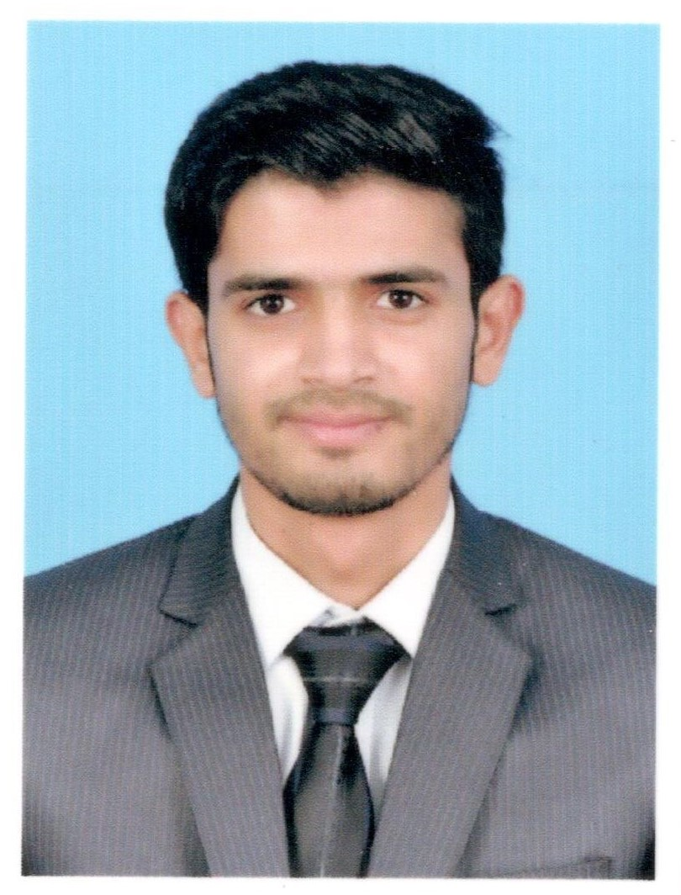
Awais Ashraf
BSc Chemical Engineer / NEBOSH IGC UK Certified
Email: awais.ashraf22@gmail.com / awais.ashraf@fatima-group.com
Contact no. +92 3404243375
Address: FG 52/6 Wafaqi Colony Lahore.

Objective
To be the part of a mature and challenging professional environment where I can effectively utilize and enhance my innate capabilities and can enhance my knowledge through practical experience.
Experience
July 2018 – Onward | Fatima Fertilizer Limited Company, Sadiqabad.
Position: Graduate Trainee Engineer (Chemical)
- Working in Operation department, responsible for safe, smooth and economical operation of the plant.
- Attend one-month training on PSM (Process Safety Management) - OSHA based standards for ensuring process plant safety and covered its all the 22 elements (which includes 10-Risk based elements and 12-Culture based elements).
Nov 2017–June 2018 | SRC (Shafi Reso Chemicals) Ptv Ltd. Lahore.
Position: Trainee Chemical Engineer
Served in Process Design Department as well as HSE department.
In Process Department worked on project “Production of Glucose from broken rice”.
Key responsibilities performed in in this regard are:
- Market based feasibility of Project.
- Lab scale experimentation for understanding process dynamics
- Material Balance Calculations
- Energy Balance Calculations
- Prepare PFD and P&ID’s as necessary.
- Equipment identification, specifications and selection.
- Setup a pilot plant for data generation.
Key responsibilities performed in HSE department are:
- Creating Safety Awareness among Employees and educate them on Safety Matters.
- Checking Permits for activities and fulfilling safety requirement as per every permit.
- Conduct Tool Box talk (TBT) daily, weekly & monthly and submit report to operations manager on daily basis.
- Run a strong campaign about a topic which is related to the safety as per client requirement and follow the HSE procedures of the client.
- Ensure that work is going safely and report to the HSE Manager of the area.
- Strictly implementation of better housekeeping for the job site and to follow the waste segregation scheme.
- Creating Safety Awareness among Employees and educate them on Safety Matters.
- Safety induction of the new employees.
Assignments Completed:
- Design of generalized Excel Program for Induced Draft Cooling Tower
- Proposed and implemented 5S system (a workplace organization method).
Internship
June 2016 - July 2016 | Four weeks internship at Lyallpur Chemicals & Fertilizer (Pvt.) Ltd Jaranwala.
- Organizational skill: Invested 4 weeks to learn about the process & production of H₂SO₄ and ZnSO₄.7H₂O.
- Multitasking: Learnt about time management, problem solving and strengthened my technical knowledge.
Education
2017 | B.Sc. Chemical Engineering | 3.58 CGPA | Institute of Chemical Engineering & Technology (I.C.E.T), University of the Punjab, Lahore
2013 | F.Sc. Pre-Engineering | 78.50 % | Govt. College of Science, Lahore
2011 | S.S.C. Science Group | 79.90 % | D.P.S School & College, Renala Khurd, Okara.
Certifications
2018 | NEBOSH (National Examination Board in Occupational Safety and Health) IGC UK Certified
Plant Design Project
Dec 2016 - Dec 2017 | Production of 100,000 ton/year of MTBE (Methyl Tertiary Butyl Ether).
- Analytical skills: Engaged quality time in research of assigned topic, invested much time in developing flow sheet and doing material and energy balances.
Memberships
- Member of PEC (Pakistan Engineering Council).
- Member of ASSE (American Society of Safety Engineers).
- Member of TYC-PU (TABA Youth Chapter-Punjab University, Lahore).
- Campus Ambassador for FootLose Adventure Club from 2015 to 2016.
Technical Skills
Basic knowledge of: | - Microsoft Office  - Aspen Hysys V8.6 | - Autodesk AutoCAD  - MathWorks MATLAB | - C/C++
Interests
 | - Computer Applications  - Action Movies | - Travelling and Exploration  - Net Surfing
References
References will be furnished on demand.

