OBJECTIVE

To join a dynamic and progressive organization offering ample opportunities for diversified experience, and seeking a position which will allow for continued professional growth, offering an environment in which advancement is based on strength of individual contributions to the realization of organizational goals.

PERSONAL INFORMATION
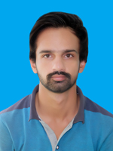
Haider Abbas Shah
Father’s Name: Sabir Hussain
Date of Birth: 11-04-1996
Domicile: Sahiwal (Punjab)
Nationality: Pakistani
N.I.C # 36502-1645046-9
Marital Status Single
Religion: Islam
Permanente Address: Clinic Dr. Islam Chak No. 82/6-R Sahiwal.
Contact No: 0333-6930145
Email: habbasshah8@gmail.com

QUALIFICATIONS

Degree | Years | Marks | Board/University
Matriculation | 2011 | 858/1050 | Fedral Board Islamabad
DAE (Electrical) | 2017 | 3055/3550 | P.B.T.E Lahore

skills

- Good command on English language
- Good command on PCs & Laptop Softwaring & Operating.
- I can do a little bit Electronics work

reference

- Will be furnished on Demand.

