Muhammad Haris khan

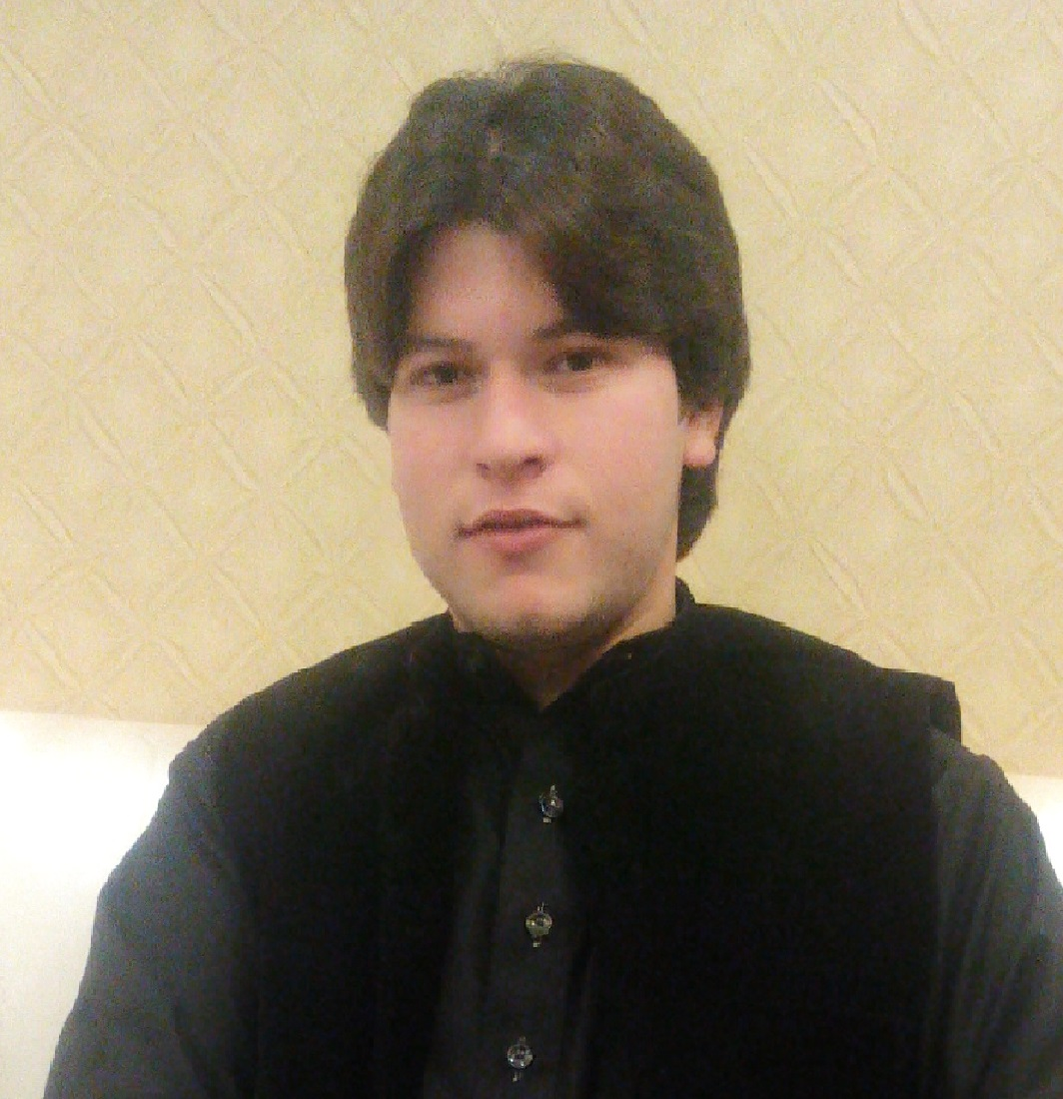
Contacts:

Address:
Nawa Kaly tehsil and district Charsadda.

Mobile #:
+923131931856

Email:
Mhkd42@gmail.com

Date of Birth:
22-05-1995

Interest:
- Photography
- Driving
- Traveling
- Playing cricket,
Football, Hockey, Table tennis, Badminton
- Surfing the internet
- And Much more

Career Objective:

I am a hardworking and highly motivated youngster and I am looking forward to start my career in a growth oriented organization where I can utilize my talent and learn new professional traits. To obtain a position with a progressive organization that provides me an opportunity to utilize my skills and expertise; which I have developed through my education.

Education:

Qualification | Board/Institution Grade | Year
SSC | BISE Mardan B | 2011
DAE | KPK BTE A | 2014
DIT | KPK TTB A+ | 2014

College Projects:

      - Design of Smart Load Management and Energy Saving System
(Final Year project)

Internships Courses:

- Two months Internship at 220 KV NTDC Grid Station Mardan

Skills:

      - Quick Learner, Good in Communication, Good in Presentation, Good in Management, Good in English Speaking and Writing.
      - MS Office, MS Power Point and Internet Surfing etc.
      - Circuit Making, PCB designing, C++

Personal Data:

- Father’s Name Farukh Sair
- Marital Status Single
- Religion Islam
- Domical Charsadda Khyber Pukhtoonkhwa
- NIC 17101-2523579-7
- Nationality Pakistani

