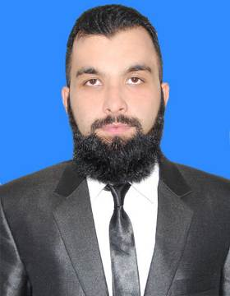
TAIMUR WAJID
0304-5198991
mohammadtaimurwajid@yahoo.com

Objective Statement
To utilize my technical skills for achieving the target and developing the best performance in the organization. I would like to implement my innovative ideas, skills and creativity for accomplishing the projects.

Personal Information
- Father’s Name | Muhammad Wajid
- Date of Birth | 24-9-1995
- Home Address | Flat, Alhaseeb Plaza, Service Road, Transformer Chowk, Sadiqabad Rawalpindi
Academic Information
- Hifz-e-Quran | AIMS Education System-F8/ 4 Islamabad (Wafaq ul Madaris)
- Matric | 2010 Grade-A BISE RWP
- FSc (Pre-Engineering) | 2012 Grade-A BISE RWP
- BS Engineering (Mechanical) | 2017(completed in July)  1st division HITEC university Taxila
Experience

Company name : Master cool engineering services/BE Engineers
JOB duration : 1 year
Designation : Trainee mechanical Engineer
Achievements
- IMEC(International mechanical engineering competition)2015 winner | Ghulam Ishaq Khan institute Sawabi
- Renewable energy resource  competition participant in 2015 | NUST RWP
- Mind Crunch Competition 2016  winner | Air University & GIKI
- Elected as Executive Member 2016 | HITEC University Character Building Society
- Became Director Events in 2016 | HITEC Press Club
Computer & Technical Skills
- Comprehensive Knowledge of MS
Word & MS Excel

- Complete Knowledge of
Refrigeration & Air Conditioning
Cycle

- Comprehensive knowledge of CREO and ANSYS Softwares

- Comprehensive knowledge of CAD software & Engineering Drawing

- Brief Knowledge of Internal
Combustion Engines & Power Plant

Languages
- English | Read Write Speak
- Urdu | Read Write Speak
- Saraiki | Speak
- Punjabi | Speak
Projects

- Designing and manufacturing of Pneumatic Air Rifle

- Designing of 3D models on CAD software and Stress analysis of different parts on ANSYS

- Manufacturing of Radio Transmitter

- Designing and manufacturing of Water Level Detector

Internships

- Pakistan Railways Carriage factory Islamabad From 15-06-2015
To 15-08-2015

- Heavy Industries Taxila From 22-07-2016
To 01-08-2016
- Askari Cement Nizampur From 25-06-2018
To 5-08-2018
References

- References available upon request

