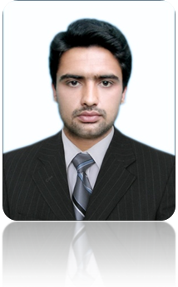
Name:-Nayab Haseen | Nationality: Pakistani
Father’s Name: -Haseen ullah jan
Permanent Address: Moh; Niamatullah Korona Kuladhand Payan Mera Umerzai  p.o Umerzai Distt. & Teh. Charsadda. | C.N.I.C. # 17101-5050675-1
 | Date of Birth:Febuary,06,1992
Cell #03469231034 | Religion :- Islam
E-mail: nayabhaseen20@yahoo.com | Domicile: Charsadda

nayab haseen
Objective | Seeking a challenging position in your reputable company to work in the field of Electrical Engineering.

summary of Education | BSc ELECTRICAL(Telecom) ENGINEERING  UNIVERSITY OF SCIENCE & TECHNOLGY BANNU
summary of Education | BSc(EE) | CGPA (3.73/4) | Grade/Division | 1st
summary of Education | HSSC
summary of Education | Certificate | Marks | % age | Grade/Division
summary of Education | F.Sc | 843/1100 | 76.63% | 1st
summary of Education | SSC (Secondary School Certificate, Science Group)  BISE PESHAWAR, K.P.K
summary of Education | Certificate | Marks | % age | Grade/Division
summary of Education | S.S.C | 613/900 | 68.11% | 1st
computr skills  InterpersonaL skills  Training & Certification  LANGUAGES | . C/C++, Matlab, AutoCAD, Ms Office, Networking.  · Leadership & Decision making skills.  · How to manage a team work.  · High communication & presentation skills.  . NATIONAL TRANSMISSION AND DESPATCH COMPANY  (BANNU).

 | . Proficient in written and spoken English, Urdu and Pashto.
HOBBIES | . Hobbies include professional enrichment working with people,  watching sites, cricket , reading books and working with computer.
Ref: Experience | . References are available on request!.

