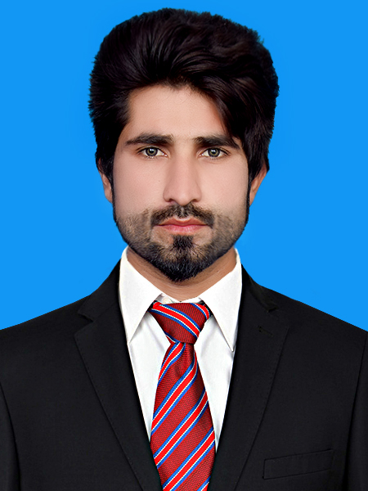

MUHAMMAD SAQIB NISAR
CONTACT # 0313-6972317
ADDRESS: Mohalla Islam Nagar Bhakkar Road Jhang Sadar
E-mail: hafizsaqib312@gmail.com
OBJECTIVE
bjective INFORMATION:

Looking for a highly challenging and dynamic work environment where I can transform my knowledge and professional skills to valuable work experience and to utilize those for securing benefits for the organization and my own self.
PERSONAL DETAILS DDEDETAILSINFORMATION:

Father’s Name : Muhammad Nisar Ahmad
NIC # : 33202-3928874-7
Domicile : Jhang
Nationality : Pakistani
Date of Birth : 14th June, 1991.
Marital Status : Single
ACADEMIC QUALIFICATION

- BSc Electrical Engineering Technology (4 year) (2012 to 2016)
CGPA: 3.36
GCU Faisalabad
- Diploma of Associate Electrical Engineer (3 year) (2008 to 2011)
Division: 1st
PBTE Lahore
- Matriculation (Science) ( 2006 to 2008)
Division: 1st
BISE Faisalabad

EXPERIENCE

- Masood Textile Mills Limited Fsd
- Internship as a Trainee Engineer in Masood Textile Mills Ltd (Faisalabad)
From Feb 06, 2016 to June 06, 2016 in Power House.

- Al-Hadi Engineering Concern Pvt. Ltd

1. Project: 1230 MW CCPP Haveli Bahadur Shah Jhang
(01 Sep 2016 to 01 Feb 2018)
. Client: power china Sepco III
Designation: Site Engineer

2. Energy Automation & Solution Engineering Lahore
(1 feb 2018 to till now)
Designation: Sales & Service Engineer

As a part of project team my duties:
- Install and terminate electrical panels & equipments in switch yard according to electrical drawings.
- To assist my superiors in commissioning
- Power House, Protection and Earthing Of Plant
- Laying of Cable Trays & Power cables
- Electrical wiring of Ceiling Lights

COMPUTER & OTHER SKILLS

Microsoft Office:
- Word
- Excel
- Power Point
PLC PROGRAMMER (Delta) (3 Months).
wpsoft
Software and Hardware Installation.
Hardware installation of Computer, Electrical and electronics equipment’s.
Power system wiring Schematics.
Chinese Language Course (4 Months)
Acheivments

- Got 2nd Position in last semester of Electrical Engineering.
- Got 4th position in Final Semester internship held in Government College University.
C0-Curricular Activities:
- Member of Government College University Blood Donor Society.
- Organized different games in Hostel Sport Gala (HSG).
- Successfully organized Farwell for our batch.

Interests:
|Newspaper, Magazines, Novels | Football, Cricket, Basketball | Socializing |Teaching

LANGUAGES

- English, Urdu, Chinese
REFERENCES

Will be furnished when asked for.

