From,

Hafiz Muhammad Waqas
Gujranwala, Pakistan.
Mobile – 0302 9752605
0348 4085018
hmwaqas588@gmail.com

Sub: Application for the post of Electrical Engineer (immediately will join)
Dear Sir,

I would like to submit an application for the position of Electrical Engineer. I believe I am suitably qualified with a degree in Electrical Engineering, relevant work experience and the skill set required to make a positive and valuable contribution to your company. Working in high pressure challenging environments has developed my capabilities in creative problem solving. My proficiencies in computer have enabled me to perform high-level tasks effectively requiring minimal assistance. My superior skill set and experience makes me an excellent candidate for the position at Electrical Systems.
I hope you find my advanced capabilities, valuable experience and relevant qualifications a suitable fit for the advertised position. I am a self-motivated individual who thrives on succeeding in challenging situations. I am passionate about Professional development opportunities and welcome every opportunity to take my capabilities to a higher level. I welcome the opportunity to meet with you in person and discuss further the contribution I can make at Electrical Systems.

.

I have enclosed my CV along with this application.

Your favorable reply in these regards will be

Thanking you.

Yours faithfully,

Hafiz Muhammad Waqas
0302-9752605

Hafiz Muhammad Waqas
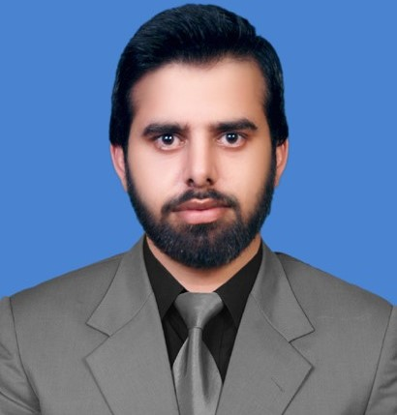

Mohalla Malik park Sui gas link road near masjid Nimmrah, Gujranwala.
+92 302 9752605 +92 317 0770537
hmwaqas588@gmail.com
Passport No.: AK7997401

SUMMARY OF SKILLS

- Team Player with Positive Attitude and have ability to work under stress.
- Strong analytical and procedural approach towards a problem
- Fluent in English, Urdu and Punjabi.
- Computer literate: proficient in MS Office, Matlab.

EDUCATION

- Bachelor of Science, Electrical Engineering (Specialization in Power)
Institute of Wah Engineering College, CGPA 3.12
University of Wah, Wah Cantt, Pakistan. Oct 2012 – Jul 2016

- Intermediate F.Sc (pre Engineering) Sep 2010 – May 2012

WORK EXPERIENCES

Employee Jan 2017 to June 2017

Gulshan Weaving Mill, Froze Wattwan.
Electrical Engineer
Shift In charge (Power plant)
Electrical Department

- Trouble shoots and solves the problems.
- Maintain Loads according to demand.
- Analyze and control all the parameters of Enginator.
- Operate PLC (start and shutdown engine).
- Synchronization of Engines.
- Made daily Assessment Report.
- Maintenance of Enginator.
- Reporting to Plant manager on regular basis for day-to-day update and planning.

Gujranwala Electricity Power Company

- 12 month experience in GEPCO as Trainee Engineer. July 2017 to july 2018

INTERN

Pakistan Ordinance Factory, Wah Cantt. July 2015 – Aug 2015
- Investigated the workings of a Power Plant.
- Interacted with the Process Laboratories.

AWARDS & SCHOLARSHIPS

- Graduated BSc. in Electrical Engineering with a first-class distinction and obtained CGPA= 3.12.
- Received Scholarships in Matric and FSc.
- Ranked in the top 10% in Electrical Engineering Examinations.

TERM PAPER & THESIS WORK

- Author of “A Project on Three phase variable frequency drive” B.Sc Thesis (2016).

EXTRA CURRICULAR ACTIVITIES

- Organizer of cricket tournament in college.
- Cricket, Table Tennis, Badminton.
- Member of Sports Committee in college.

PERSONALS
Marital Status: UN Married
Religion: Islam
Date of Birth: December 15, 1993

