SAMI ULLAH 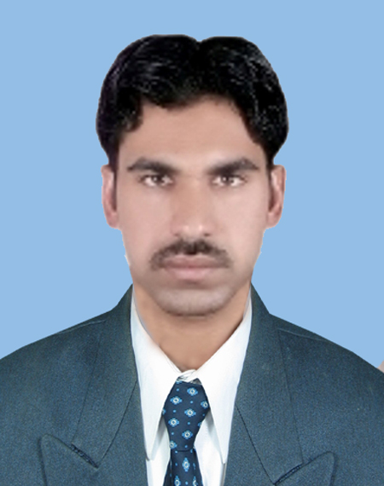
Cell No: (03472349133)
Samiullah515@yahoo.com
Objective:
To enter the professional life for applying the various technical, management and decision making skills. Qualified for a professional career and ready for new responsibilities and learn in a competitive environment and gain experience along the way.
Personal Profile:
Name : SAMI ULLAH
CNIC : 14203-0588837-5
Nationality : Pakistani
Domicile : karak (K.P.K)
Religion : Islam
Date of birth : 3rd Sep 1991
Marital Status : Single
Present address : FF Steel Peshawar
Permanent Address : Village and p/o muhabbati killa karak.kpk

Qualification: `
Degree Institute Year Div./Grade/%age

BSc Mechanical UET Peshawar 2014 CGPA 2.82
Engineering

F.Sc (Pre-Eng.) Danish public school and college
Chokara karak . 2010 A1/82.72%

Matriculation Danish public school and college
Chokara karak
2008 A1/80.11%

Experience:
- Worked in FF Steel Mill as a Q.C Engineer (01 year).
Key Responsibilities:
- Worker management.
- Daily attendance report to General Manager.
- Prepare weekly quality meeting.
- Checking and control quality of steel bars.
- Physical testing of steel bar on UTM.
- Preparing job card for materials demand.
- Chemical testing of raw materials (Billets).
- Insures samples of different steel bar sizes.
- Working now as a maintenance engineer (Workshop & Fabrication) 01 year and still continued.
Key Responsibilities:
- Prepare daily attendance sheet.
- Assigning daily task to Forman.
- Checking MIL (minimum inventory list) weekly.
- Inspect daily task on sharp floor.
- Making job cards for materials on requirement.
- Assign daily work to Fabrication Incharge.
- Prepare monthly incentives for workers.

Mini Projects:
- Pattern making.
- Twist measuring instrument.
- Project Management.
- Identification of Heat Treatment Process.

Course Project: Mould design and analysis through ANSYS Fluent software.

Computer Skills:
- MS Office, Power point, Excel.
- MS project.
- Adobe Photoshop.
Personal Information:
Languages: Fluently speak and write Urdu, Pashto, and English.
Qualities: Communication skills, conflict resolution, providing leadership and motivation to working groups.
Extra Co-Curricular Activities:
- Playing Cricket. Reading newspaper.
References: Will be provided on request.

