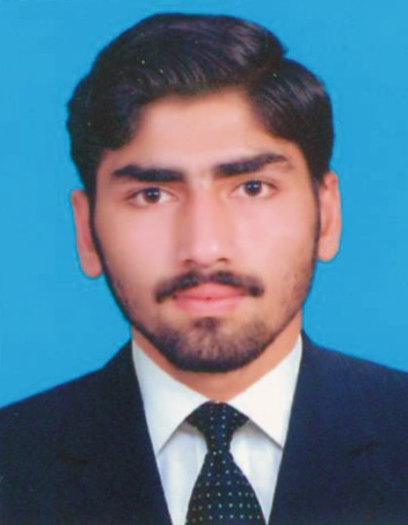
MUHAMMAD ARSALAN
Cell Number : +92332-9538263
Address: House No. E-257 Ghazi Barotha Power Complex
Colony Attock Punjab Pakistan.
Email:- farhanabid254@gmail.com

OBJECTIVE :

To seek a challenging and responsible position in a dynamic organization that could utilize my skills and experience and would like to accomplish best result in tough and tidy schedules and to work with the team of professionals where I can enhance my skills.
PERSONAL PROFILE :

Father Name : Abid Hussain
Nationality : Pakistani
Domicile : Chakwal (Punjab)
Religion : Islam
Martial Status : Single
Date of Birth : 02nd April 2000
CNIC : 37201-1320855-9
ACADEMIC QUALIFICATION:
Certificate | Year | Board/University | Marks Obtained
S.S.C(Science) | 2015 | B.I.S.E Rawalpindi | 603/1100
D.A.E (Elect:) | 2018 | Technical Board Lahore | 2822/3550

Technical Experience

- Have Six Months COMPUTER COURSE From FAUJI FOUNDATION
PROFESSIONAL EXPERIENCE :
TECHNICAL TRAINING Center Attock.
- Have Six Months MOTOR WINDING COURSE From FAUJI FOUNDATION
TECHNICAL TRAINING Center Attock.

