CURRICULUM VITA E 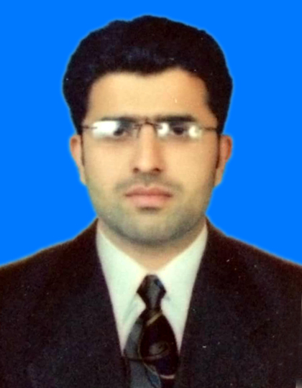

HUSSNAIN ALI
Email Address: alihussain7676@gmail.com
Contact: +923322311212 ,+93026657527

PROFILE:
A hardworking, reliable and enthusiastic person with a diverse range of finance, retail and customer services experience. Outgoing with strong and effective organisational and communication skills. Good team player and able to use own initiative to achieve company objectives. A mature, confident, hardworking, strong communicator, reliable person and I have an analytical approach. I believe I am self-motivated and have the passion and willingness to learn. These skills have now come into my daily life practices. As an exceptionally ambitious individual I thrive to challenges and have the motivation to succeed. I am continuously thriving for the future and committed to engaging and working with others to proactively and have the ability to support business growth and change. As an individual with high potential and leadership capabilities, I have a positive attitude.
KEY SKILLS:
- Efficient analytical skills with a high aptitude
- Excellent customer service, communication and time management skills
- Good relationship management skills and natural problem solver
- Flexible and great team player, with the ability to work to tight timescales
- I have complete knowledge of Microsoft office and outlook and also have experience of using internet at associate level.
- I have likeable, approachable, convincible and pleasant personality matched with a good sense of humour, enabling me to communicate and collaborate with diverse people, achieving a positive outcome.
- I am always keen to get involved with team discussions. This has proven invaluable in the development of my communication skills, teamwork skills and confidence. I have also been proven to be a flexible and motivating member of a team via is direct or indirect.
- I have good communication skills and proficient in English.

ACADEMIC QUALIFICATION:

COURSE | INSTITUTE | GRADE | YEAR
BSc Electrical Engineering (Power) | The University of Lahore | 3.26/4 | 2011-2015
FSC | The Educator College Multan | B | 2011
Metric | Board of intermediate & Secondary Education, Multan | A | 2008

EXPERIENCE HISTORY:
Team leader in Myson Engineering system (Feb-2018)

Myson PAKISTANI Engineering SERVICES & Company) for ptcl sites &

Responsible for Nokia Pss Rack for commissioning managing the Preventive and Corrective Maintenance of backup power systems and commercial power supplies.Responsible to Control Complete Implementation, Installation,
commissioning, operation, Maintenance a calibration of rectifier (-48) Like
Eltek, Emerson, and soft power.
Solar Energy System, FCB, GLO, Battery Project ,Power Cube, APM30,UPS,
Fire Alarm System (Fire tech), MAB, Horizon, Tyco, Ban Tell) Generator
ATS Panel, Power & Control System A.C and D.C Power System Rectifier

➢ Smooth operation and coordination

➢ Daily down Time Analysis & justification Installation and commissioning

➢ Installation of All type of (Indoor/outdoor) equipment

➢ Trouble shooting of Down/low efficient sectors VSWR handling and Rhooting

➢ All types of Alarms patching and reporting at terminal

➢ Offline commissioning Installation and trouble shooting of rectifier

MEHMOOD TEXTILE MILLS MUZAFARGARH June 2015  June 2016
RESPONSIBILITIES:
- Worked as a Junior engineer.
- My responsibilities were 20 MW power plant installation and see E&I on new installation.
- Read charts, meters, and gauges to monitor voltage and electricity flow
Check equipment and indicators to detect evidence ofoperating problems
Adjust controls to regulate the flow of power

HAMAD TRANSFORMER ENGINEERING COMPANY MAY 2014 MAY 2015
RESPONSIBILITIES:
- Worked as a junior engineer.

THERMAL POWER PLANT. Dec 2015 Jan 2016
RESPONSIBILITIES:
Worked as 1 month as internship as a Engineer at thermal power station Muzaffargarh (1350MW)
.Total unit 6 (5 units) having capacity 210 MW each and 1 unit of 300MW.
.Each boiler having capacity 640 ton/h steam production. Tandem compound turbine connected to generator rotor (HPT,MPT,LPT)
OTHERS SKILLS:
➢ Good interpersonal and communication skills
➢ Project coordination and technical support.
➢ Leadership skills
➢ Project Management
➢ Project Planning Skills.
➢ Presentation & negotiation skills.
➢ Effective problem solving skills
➢ Good Statistical Analysis and technical reporting/presentation
skills.
➢ Good interpersonal skills and be strong team player
➢ Good knowledge of MS Office (Office, Excel, Word & Outlook)
PERSONAL DETAILS:
Name : HUSSNAIN Ali
Nationality : Pakistan
Date of Birth : 10/02/1994
Passport No : MJ1815021
Passport Expiry : 15/05/2021
Marital Status : Single

