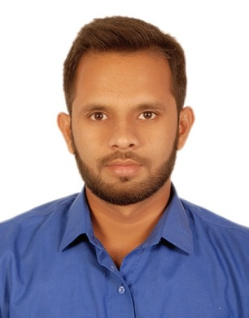
Fahim Iqbal
Date of Birth: June 23rd 1996
Address: Flat D-21 Iqbal Plaza Phase II, Sector 11-C/1 North Karachi, Karachi.
Contact Details- Cell #: 00923472409522
Email: fahimbee@gmail.com CNIC NO: 42101-0182662-1

Personal Statement

‘Learn – Grow – Lead’


Objective:

To be an effective part of a creative team, seeking a challenging role in a dynamic organization
where opportunities of career growth & learning exist, in order to contribute to organizational goal.

Experience:

RF ENGINEER

Company: LCC Pakistan (Pvt) Ltd
Duration: March 2018 to Present

Responsibilities:

- Telenor relocation DT Project.
- Designing high power and low power RF electrical components and interconnects.
- Worked in 2G/3G LTE Roll out project.
- Designing high power and low power RF electrical components and interconnects.
- Usage of RF and EM (electromagnetic) simulation/ design tools to ensure robust and efficient product design.
- Solves complex and ambiguous problems. Perform trouble shooting (at bench level and system level) encompassing multiple variables to achieve root cause analysis and problem resolution.
- Develop robust designs for new or existing products that can be produced economically and according to established project timelines.
- Working on TEMS Investigation (16.1.1) Software.

INTERNSHIP:

- 60 days Internship in LCC Pakistan (Pvt) Ltd from 1st July 2017 to 31st August 2017
- Visit Pakistan cable to understand how to make a copper cable from copper plate sheet

Academic Qualifications:

Education | Majors | Year of Completion | Institution
BEE | Electronics | 2018 | Bahria University Karachi
HSC | Pre-Engineering | 2014 | Islamia Govt Collage
SSC | Science | 2012 | Programmer Secondary School

Final Year Project:

- Exoskeleton for Physiotherapist.
- Computer Skills:
- Microsoft Windows XP, 7 & 8, Visual Basics, Internet & Graphics Animation
- Tems Investigation (16.1.1) , MATLAB, LABVIEW, Microsoft Office 2003 &2007-10.
Reference : Available on Request.

