Mohsin Abbas
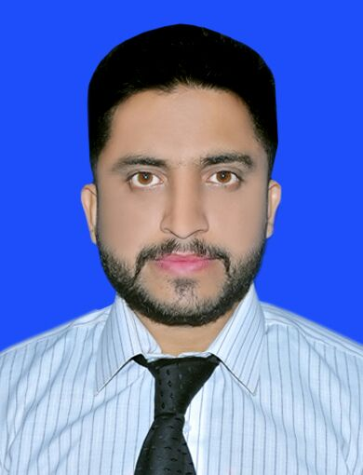

House # 22, Service road, block “G”
Naval Anchorage Islamabad,
Pakistan.
Cell: +92-313-5451182
Nic: 42201-3881263-1
mohsinabbas108@yahoo.com

OBJECTIVE
To work hard with complete devotion for the better development of the organization, like to take challenging tasks so as to assess my own capabilities and want to provide benefits to my organization. With proficiency in industry standards, ready to build company reputation with innovative applications and designs.

PROFESSIONAL EXPERIENCE

PTCL Satellite Town Rawalpindi (June 2016 - July 2016)
- Work as an Internee Engineer for 6 weeks at PTCL Office Rawalpindi.
- Work in Exchange Office, NGN, GPON, Optical Fiber and switching department.

Islamabad Electric Supply Company (IESCO): (July 2016 - Aug 2016)
- Work as an Internee Engineer for 4 weeks in IESCO Rawalpindi.
- Work in Grid station.

Attock Refinery Limited (ARL) (Jul 2015 – Aug 2015)
- Worked as an Internee Engineer for 6 weeks at Attock Refinery Ltd Rawalpindi. Instrument and Measurement department.

EDUCATION

Bachelor of Electrical Engineering (BEE Electronics) Sep 2013 – June 2017
Bahria University Islamabad (GPA-3.53) (CGPA-3.16)
Higher Secondary School Certificate (HSSC) 2010 - 2012
Bahria College Karsaz Karachi (Karachi board) (68%)

SSC 2010
Bahria College Karsaz Karachi (Federal board) (67%)

FINAL YEAR PROJECT

- Pulse Oximeter (sensor)
Description: Pulse Oximeter is a medical device used in many hospitals as well as in many clinics, which helps in measuring the saturation of oxygen in the blood. The device is designed using Red LED, IR Transmitter, and Photodiode. Furthermore we have a microcontroller and an LCD to display the output. Pulse Oximeter device uses the principle of absorption on the basis of which a ratio is find out between the IR and Red led to calculate the oxygen saturation level.

ACADEMIC PROJECTS

- Fire Alarm System  - FM Transmitter  - Home Automation System  - H bridge circuit  - Auto Light Control  - Online Library system (C++ programming) | - Sound level detector (Using LM741)  - Bank counter (8051 controller)  - Image processing (using MATLAB)  - FM Jammer  - Digital Equalizer (Using Simulink)

MAJOR COURSES

FPGA, Power Electronics, Industrial Automation, Linear Control System, Linear Integrated Circuit, Microprocessors & Interfacing, Communication System, Digital Signal Processing, Electro Mechanical System, Electric Network Analysis, Electronic Devices & Circuits, Digital Logic Design, Data Communication & Networking, Basic Electronics, Instrumentation & Measurement, Computer Architecture, and Object Oriented Programming.

SOFTWARE SKILLS

- Pspice  - Auto cad  - Proteous  - Visual studio C++  - Microsoft Office (Excel, Word, Power Point)  - Adobe Photoshop  - PLC programming (Ladder)  - Microcontroller (8051, Arduino) | - Verilog  - Multisim  - Keil  - Packet Tracer  - ISE xilix software  - Matlab  - Simulink  - Web Designing html (beginners)

PROFESSIONAL SKILLS
- Hardware skills
- Good in mathematics
- Good management skills
- Good Communication skills

ACHIEVEMENTS

- Automation and Control System (Seminar by IEEE 2016) at Bahria University Islamabad.
- Participated in Manora Mini Marathon race (PNS HIMALAYA Karachi 2010) from Bahria College Karsaz Karachi.

L ANGUAGES
- English
- Urdu
- Punjabi

