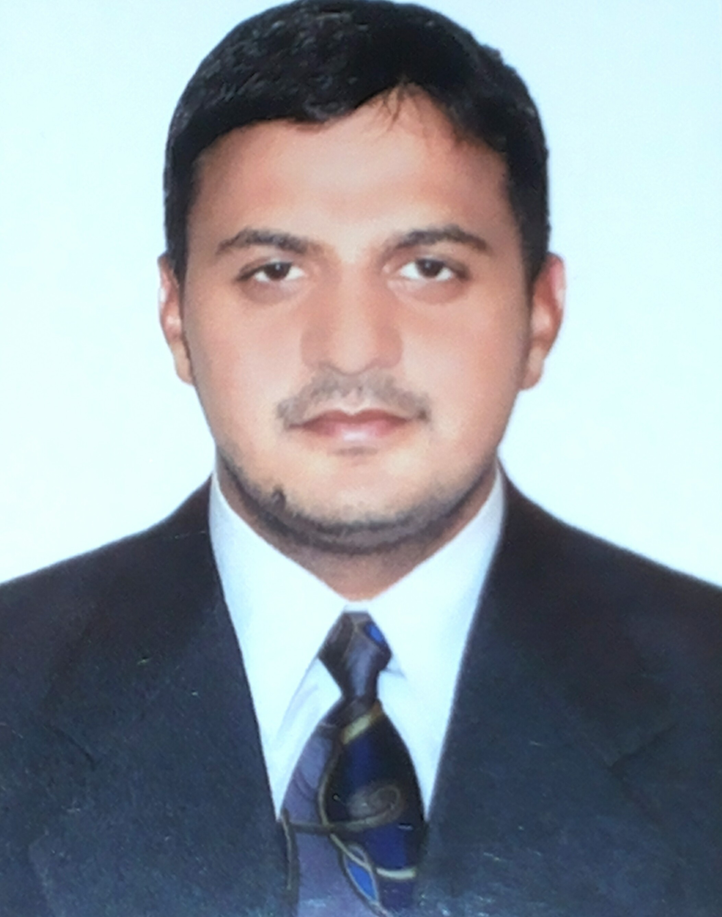
MUHAMMAD NASEER
Email .amnaseer61@yahoo.com
Mobile: +92 3366644048 Father Name: M Amin
Date of birth: 01-01-1992
N.I.C NO: 35301-1368534-1
Passport No.: EC9825341
Nationality: Pakistan
Mobile: 03366644048
Address: Muhala phir islam jinaz gha road Haveli lakha Dis. Okara

Highly Proactive, devoted and team spirited professional Electrical having about 1 year of professional experience in Bilal Switchgear Engineering {PVT} Ltd Lahore, Pakistan, and 4 years of professional experience as a Electrical department in Kahramana Elect.Cont.& A/C Fix llc, sharjah UAE.

Objective is to work in an exciting and professional environment of a dynamic organization with personal development and growth possibilities and to achieve company's goal through professional ethics, sincere commitment and hard work.

Core Competencies

+, Experience all construction work ,CCTV cameras , labour control, reading drawing .
+ in Industrial Process Automation

Professional Experience

Kahramana Elect Cont & A/C Fix LLC ,UAE Dubai
Sep 2012 - Dec 2016

- 4 years expriance in BMS Emair tower office Electrical Work 27 floor (2703) and 13floor (1301,1302)
- The villa Society in Dubai
- Kahwaneej park in Dubai
- G+3 Ajman
- Hundred Villa Project FUJRAHA
- The villa Society in Dubai
- Silicon G+8 dubai
.

Bilal Switchgear Engineering {PVT} Ltd Lahore, Pakistan
Aug 2011 - July 2012

      - Working as a,L.T panels
      - Power Light Distribution Board, Plants Reporting directly to the Manager of Operations
      - Ensuring all quality standards to be followed
      - Motor Control Automatic Changeover Panels Automatic configuration Air Conditioning Panels, industrial Tube

ACHIEVEMENTS & APPRECIATIONS

- Registered Educator from Higher Education Commission Pakistan

- UAE Examination: (Sharjah Electrical and water Authority)
I have passed the Examination of Sharjah Electrical water Authority General Electrician.
{Federal Electricity & Water Authority} have passed the examination General Electrican.

Computer Platform
I have 6 month's Diploma in CCNA , MS Office, In page, , Windows Operating System 98 XP and Vista, Troubleshooting of Computer Hardware and Software.
1 Year experience as a Computer Operator Smart School Haveli lakha

Educational Credentials
0808
(DAE) Diploma of Associate Engineer in Electrical (PBTE) Lahore | 2011
(SSC) , Govt High School NO 1 haveli lakha Dis Okara ,Pakistan | 2008
(CCA) Cartificate computer Application Off Govt Comrace college Bahawal Nager  (PBTE) Lahore | 2011

Affiliations & Attestation

- Higher Education Commission
- Ministry of Foreign Affairs
- UAE Embassy in Pakistan

Hobbies

- Calligraphy
- Social Works
- Reading books

Languages

- English, , Urdu, Panjabi

Reference

Will be furnished upon request.

