IHSAN.UL.HAQ
S/O ZAIN.UL.HAQ  Postal Address:  Shami road Hassan garhi FG colony Peshawar house no.FG/39  Date of Birth: September 01, 1993.  Married, Muslim, Pakistani. | NIC# : 16101-7682708-7  Cell No: +92-3469110788  Email: ihsanulhaq256@gmail.com
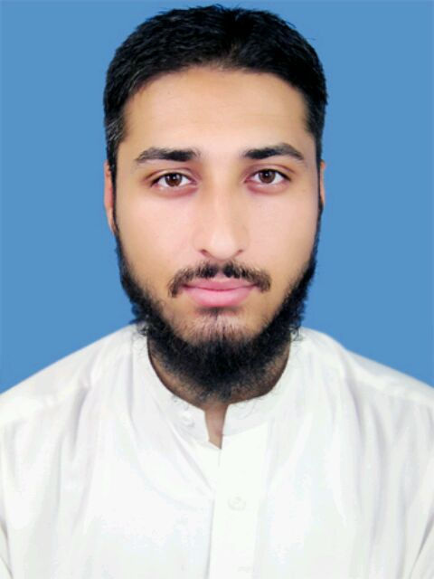

Career  Objective | To work in such a dynamic environment where I can improve my educational skills and utilize and enhance my capabilities, knowledge and talent in a feasible manner for the benefit of the organization that encourages innovation and inspiration in the job process.
A  c  a  d  e  m  I  c  History | Graduation | B.S.c  (Electrical Engineering)
A  c  a  d  e  m  I  c  History | 2012---2016 | IQRA national university Peshawar.  CGPA 2.76/4 : 69%
A  c  a  d  e  m  I  c  History | Intermediate | Pre –Engineering
A  c  a  d  e  m  I  c  History | 2010-2012 | Warsak model school and college Peshawar.  Result: 757 / 1100 : 68.81 %
A  c  a  d  e  m  I  c  History | Matriculation | Science Group
A  c  a  d  e  m  I  c  History | 2008-2010 | Students’ academy warsak road Peshawar.  Result: 695 / 1050 : 66.19%
Final Year Project | Model and Design for the Control of Hybrid Domestic Power System  - The main aim of any electric power supply in the world is to provide uninterrupted power supply at all times to all its consumers. The design has been made which combines renewable energy sources.  - Solar energy has been proposed to be implemented as on-grid hybrid power system.  - Generator has been connected in the design as back up source so that the system is reliable. Single central controller is proposed instead of several controllers, this will make system more cost effective and efficient.  - Load distribution has been made for the ease of sources management
Main subjects | Power system, Electronics, Power Transmission and Distribution, Industrial Electronics, Signal and system, Communication system, OOPS, Microprocessor Architecture and Assembly, Digital logic design, Basic Electrical engineering power Generation, Control System, DSP, Electrical machines.
INTERSHIP | Two month in Tesco Peshawar  Work in grid stations
EXPERIENCE | - PAK PWD  From 01-09-2015 to 31-1-2016  - Durr Peshawar Ceramics (Pvt) Limited.  From 01-02-2016 to 01-02-2017  - PEDO
Computer skills | - Windows (2000, Xp,7,8, 8.1), MS Office, Protius , Keil, AutoCAD, Electronic Work Bench, PCB wizard, MATLAB, / C++, Microcontroller assembly language (8086).  - Excellent typing skills.
Other skills | - Best management and excellent interpersonal communication skills  - Command on Fluent Urdu, Pashto and English Languages.  - Excellent presentation skill  - Hafize Quran
Other Activities | - Searching new technologies like computers, mobile phones and tablet PCs.  - Playing cricket  - Internet

