MUHAMMAD HAMMAD
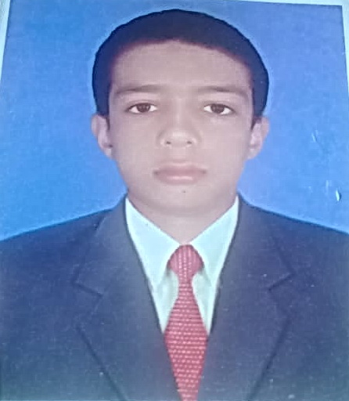

Village Maingri Gujran, P.O. Noor Kot, Tehsil Shakargarh, Distt. Narowal
Mob: +92 307 4280765
Email: muhammadhammadtariq996@gmail.com

OBJECTIVE

Seeking an internship position with growth-oriented company offering opportunity for skill and professional development to surpass in the field of Mechanical Engineering.

EDUCATIONAL QUALIFICATIONS

- Examination | - Year | - Institution | - Marks Obtained
Diploma of Associate Engineer | 2018 | Mehmood Khan Govt. College of Technology for Boys, Narowal | 2917/3450 (A+)
SSC | 2015 | Govt. G.D Islamia Higher Secondary School Maingri, Distt. Narowal | 841/1100 (A+)

PROJECTS
Final Year Project:

Semester Projects :

SOFT SKILLS

- An out of box thinker and a team player with good communication skills.
- A keen learner with a strong desire to succeed in whatever challenge I am given.
- Equally strong as an individual, self-motivated and confident in dealing with challenges.
- Particular strength is working under tough deadlines.
- Always ready to run an extra mile in order to present solutions to the problems.
- Can easily adapt to any environment and always willing to experiment.

TECHNICAL SKILLS

- Competent in MS Office Suite & Operating Systems

LANGUAGES

- English, Urdu, Punjabi

PERSONAL INFORMATION

Father’s Name : Muhammad Tariq
Date of Birth : 07.06.2000
CNIC 34502-1993043-3
Domicile: Punjab

Marital Status: Single
REFERNCES

- References can be furnished upon request.

