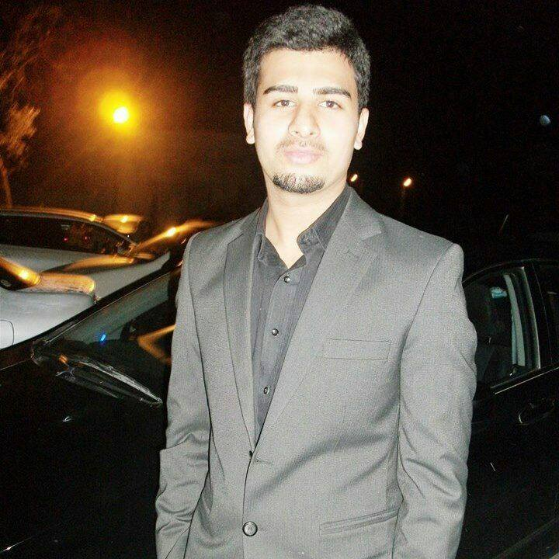

UMER ZAHEER ABBASI

omerabbasii16@gmail.com
0332 8514741

PERSONAL STATEMENT

Innovative. Industrious. Talented. Mechanical Engineer with proven track record in learning new design skills since graduating with a Mechanical Engineering degree in 2018.
I would like to implement my educational skills in similar domain in order to enhance my professional skill by getting internship opportunity in renowned organization.

KEY SKILLS

Technical Skills
- SolidWorks
- MS Office
- Microsoft Project

Internship
- Fauji cereals Rawalpindi

EDUCATION

- Mechanical Engineering from University of Lahore
- (Pre-engineering) Fsc Fauji Foundation College
- Matric Fauji Foundation School

Project topic:
- Design and study the variable valve timing of an IC engine

Work experience:
I am good at MS Word, making impressive presentations in PowerPoint, manage things well according to time and situation. I already have an experience of internship.

PERSONAL INTERESTS

Traveling | Reading | gaming | youtubing

