AHMER WASEEM

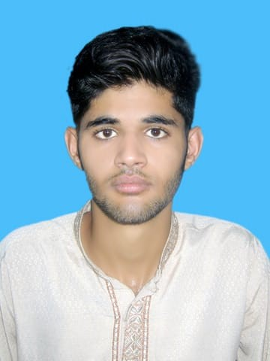

OBJECTIVE
To work for a dynamic and growing organization in challenging environment, where I can contribute to its growth while enhancing my professional abilities

PERSONAL PROFILE

- Father Name WASEEM AKHTAR QURESHI
- N.I.C No 61101-9573337-5
- Date of Birth 18-12-1998
- Domicile Islamabad
- Marital Status Single
- Religion Islam
- Nationality Pakistani
- Address House # F-32 NIH Colony Chakshehzad Islamabad
- Phone No 0332-9980665
- Email Address Aq105259@gmail.com

QUALIFICATION

Degree | Year | Board/University | Division
DAE(Mechanical) | 2018 | PBTE Lahore | 80%
Matric(Science) | 2015 | FBISE | 64%

COMPUTER SKILL

MS Office( Word,Excel,Power Point)

EXPERIENCE

- 6 Months Technical Experience at Aqil Electric Works Rawalpindi

INTERPERSONAL SKILL

- Able To Work under Pressure and Meet Deadlines.
- Familiar how to work with a team.
- Creative.
- Can play a meaningful role in the development programs.
- Optimistic Nature.
- Good sports man spirit.
- Strong Analytical Skills

LANGUAGE
- Urdu
- English

