
URRICULUM

ITAE

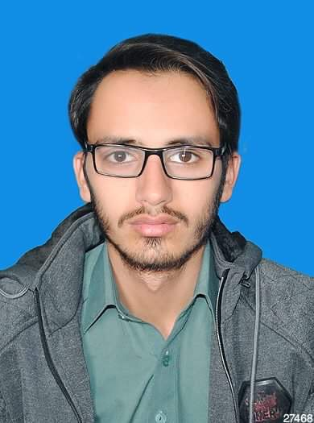
Ubaid Khawaja

(B.Sc. Electrical Engineering)

Address: C-17 Data Hamlet Housing Society Data Mansehra.

Cell no: +923417888213

E-mail: ubaidkhawaja03@gmail.com

Objective:

I aspire to attain a challenging position in an organization where I can make use of my engineering knowledge and expertise in the development and growth of the organization.

Personal profile:

 | Father’s Name: |  |  |  | Peerbakhs Khawaja
 | Date of Birth: |  |  |  | 04-03-1996
 | CNIC: |  |  |  | 13503-7926227-5
 | Marital status: |  |  |  | Single
 | Domicile: |  |  |  | Mansehra (KPK)
 | Nationality: |  |  |  | Pakistani
 | Religion: |  |  |  | Islam
 | Educational Background:
 | Qualification |  |  | Institute |  |  |  | Board/University |  |  |  |  | Duration
 | B.Sc. Electrical |  |  | Swedish College of |  |  |  | University of Engineering and |  |  |  |  | 2014-2018
 | Engineering |  |  | Engineering and |  |  |  | Technology, Taxila
 | (3.87/4.00 CGPA) |  |  | Technology, Wah Cantt.
 | Higher Secondary |  |  | National College Of |  |  |  | Board | Of | Intermediate | And | 2013-2014
 | School Certificate |  |  | Sciences, Mansehra. |  |  |  | Secondary Education, Abbottabad
(802/1100)
 | Secondary School |  |  | Garden Public High |  |  |  | Board Of Intermediate And |  |  |  |  | 2010-2011
 | Certificate |  |  | School, Mansehra |  |  |  | Secondary Education, Abbottabad
 | (796/1050)




Specialized Skills:

IT Skills |  | MS Office,Word, Excel,
 |  | PowerPoint, End note
Technical Skills |  | Auto CAD2008
 |  | Power Plant
Personal Skills |  | Leadership, Target Driven, Creative
Semester project |  | Power Generation Through Piezo Electric Sensor, Transformer Model, DC Power Supply | .
Experience |  | Fresh

References:

References will on demand.

2

