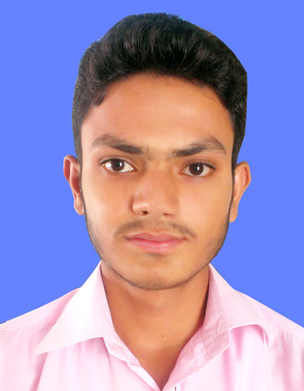
REHAN HAIDER
v
C
Mohalla Ali Nagar, Near Masque Almadina,
Badar Sher, Bahawalpur.
Contact #: 0308-8554434
E-mail: rehanhaider686@gmail.com

Objective: Seeking a career with a suitable job according to my Qualification and ability, which will provide me the platform to become a well-recognized professional. Ultimately attaining prestige and pride for the organization and myself.

Personal Information:

- Father’s Name: Sajjad Haider
- Date of Birth: 05-06-1996
- Nationality: Pakistani
- C.N.I.C: 31202-2430088-3
- Religion: Islam
- Domicile: Bahawalpur
- Gender: Male
- Marital Status: Single

Qualification:

Degree | Marks | Passing Year | Division | Board/ University
DAE (Chemical) | 2522/3400 | 2016 | 1ST | P.B.T.E Lahore
Matric (Science) | 651/1050 | 2013 | 1ST | BISE Bahawalpur

Computer Skills:

- Microsoft Windows.
- Internet Browsing.
- Microsoft Office.

Experience:

- 1 Month Training in PCRWR Analysis of Drinking Water Quality Parameters.
- 2 Month Experience in KAPCO Shutdown Work.
- Now Work at Masters Graphics (Adobe & Graphics Designing).

Languages:

- English.
- Urdu.
- Punjabi.

References:

- Will be furnished on demand.

