PERSONAL INFORMATION | Malik Hammad Nazar
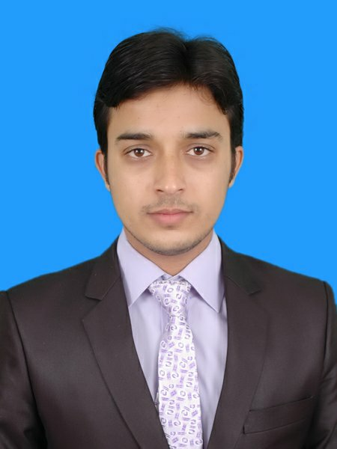 |   House # 275, street # 20, Sector I-10/2, Islamabad, 44000, Pakistan.   +92-336-4000611

051-4445817


engrhamad20@gmail.com
 | Sex Male| Date of birth 10/01/1995 | Nationality Pakistani

personal statement | To strengthen my professional skills, aptitude which I have acquired through education and interpersonal relationships in professional settings.

WORK EXPERIENCE

September 3, 2018-  To present  November 1, 2017-  April 30, 2018  July 30, 2015-  August 30, 2015 | Internee at Zarai Taraqiati Bank Limited.  - Responsible for internet connectivity for users through "HELP DESK Support System". I am also working on LAN and switches configuration.  - Worked on VPDN network  Internee at Pakistan Software Export Board, Ministry of Information Technology.  Shahbaz Ahmad, Assistant Project Manager, 2nd floor, Evacuee Trust Complex, Islamabad, Pakistan  - Worked on Computer Networking equipments like routers, switches, hubs etc. I was responsible for trouble shooting, maintenance and security of a local area network. I have also participated in network deployment activity.
Internee at AASK corporation pvt. ltd.
Shiraz Shahid , Dirtector Technical, Unified Dlabs pvt. ltd. (+92-321-8469760)
- Worked on Street Light Control Panels and Power Transmission.

EDUCATION AND TRAINING

September 2, 2013 -  September 15, 2017  September 1, 2011-  September 23, 2013  June 4, 2009-  August 2, 2011 | BS Electrical Engineering  Specialization: Computer.  COMSATS Institute of Information Technology, Wah Cantt, Pakistan.
HSSC (D.G. Khan Board)
Subjects: Physics, Maths, Chemistry.
Misali Zakariya Higher Secondary School, Muzaffargarh, Punjab, Pakistan.

SSC ( D.G. Khan Board)
Subjects: Physics, Maths, Chemistry, Biology.
Misali Zakariya Higher Secondary School, Muzaffargarh, Punjab, Pakistan.

PERSONAL SKILLS  Mother tongue | Urdu
Other languages | UNDERSTANDING |  | SPEAKING |  | WRITING
Other languages | Listening | Reading | Spoken interaction | Spoken production
English | 5.5 | 5.5 | 6.0 | 6.0 | 6.0
 | IELTS Academic 6.0 Bands Overall

Communication skills | I have learned much stronger communication skills during my internship at Pakistan Software Export Board. Example:  - good communication skills gained through my experience as an internee. In this duration, I have to talk to the representatives of other companies in order to manage and deal with the things related to my work.

Digital skills | SELF-ASSESSMENT
Digital skills | Information processing | Communication | Content creation | Safety | Problem solving
 | Proficient user | Proficient user | Independent user | Proficient user | Independent user
I gained few computer skills during my bachelor and few skills from short courses like CCNA,CCNP etc.
- good command of office suite (word document, spread sheet, power point software)
- good command of Networking software like Cisco Packet tracer, GNS3, putty.
good command of simulation tools like VMware, Proteus and Java web start

Other skills | Badminton Painting  Outing Cricket

Driving licence | National Highways and Motorways Police-Pakistan.  Licence # 00013980-isb

ADDITIONAL INFORMATION

Presentations  Projects  Seminars  Memberships  Courses | Projects presentation:  - Semester projects.  - Final year project.  Class presentation on:  - Report Writing Skills.  - Entrepreneurship.  - Electric circuits analysis.  Final Year Project:  - Direction Finding Robot (Drilling Robot).  Semester Projects:  - Temprature controlled electronic fan regulator.  - Quiz buzzer using 8051 microcontroller.  - Audio amplifier.  - Wireless energy transmitter.  Cisco project life cycle.  Pakistan Engineering Council ELECT/64916  Registered Engineer with PEC Under Washington Accord.  Cisco Certified Network Professional (CCNP)  Cisco Certified Network Associate(CCNA)

