
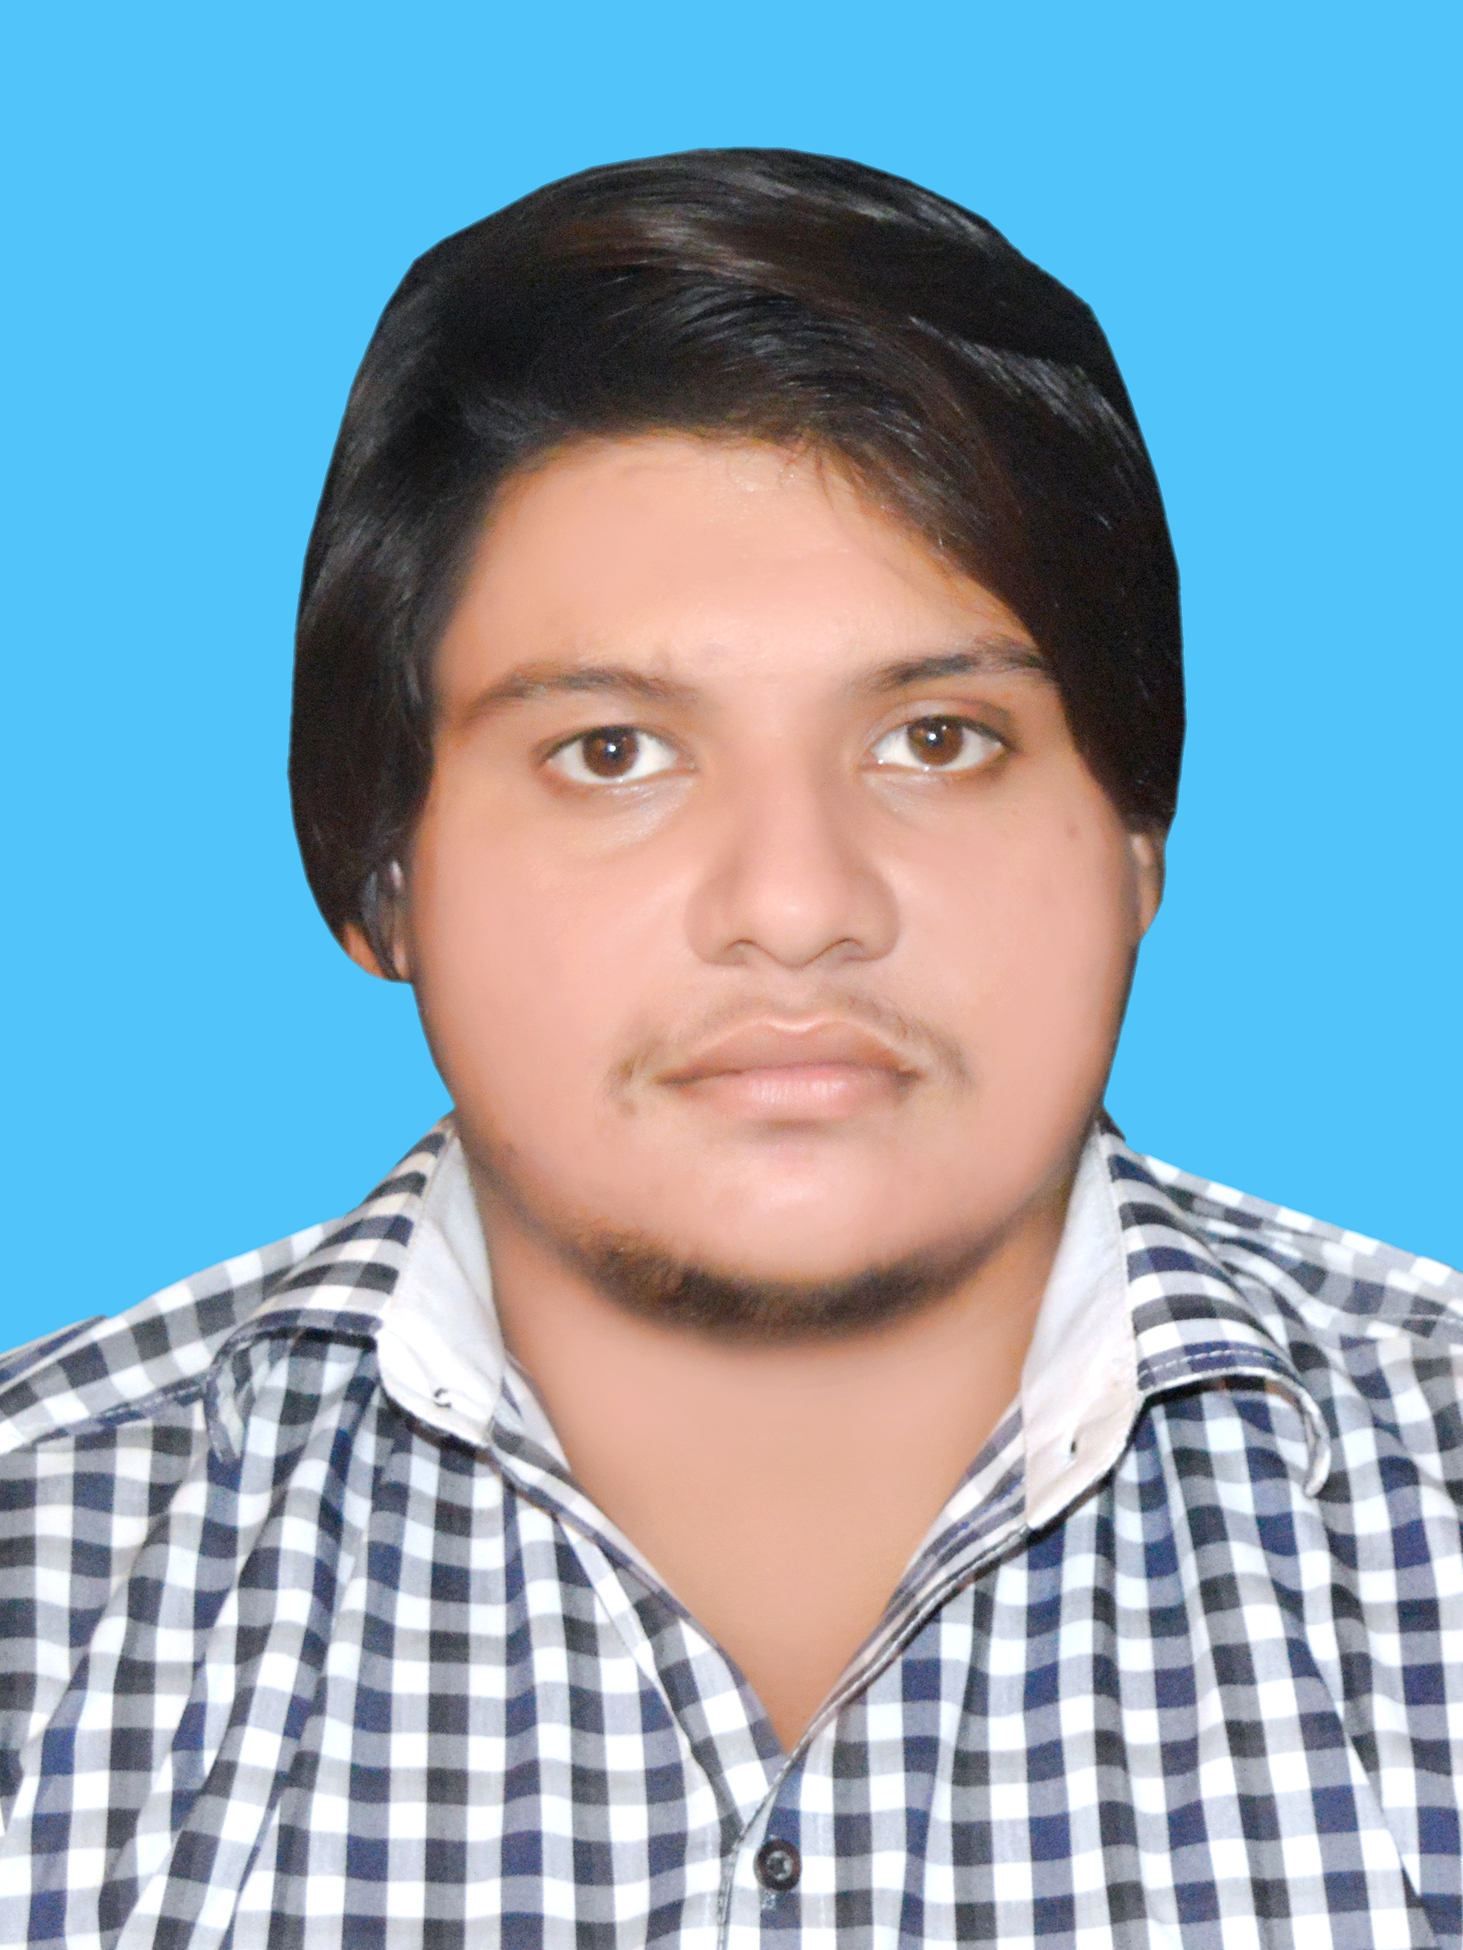
Address: Street No House No 09 House No. 1/4, P/O Sarai Sidhu Khass Tehsil Kabirwala District Khanewal


raoadnanittifaq@gmail.com
Cell: 0306-7347036 – 0333-2627413


Rao Muhammad Adnan Ittifaq

Objective:-


Seeking a challenging and growth oriented position in a professionally managed organization where I can utilize my skills and the qualification for the benefit and growth of the organization. Continuous improvement in my skills with exploring new horizons

Personal Information:-

Father’s Name Muhammad Ittifaq Aalam
CNIC# 36102-2023179-5
Date of Birth 01-09-1999
Marital Status Single
Nationality Pakistani
Religion Islam

Academic Record:-

Degree | Year | Marks | %age | Board
Matric | 2014 | 716/1100 | 65.09% | BISE Multan
DAE (Electrical) | 2017 | 2738/3550 | 77.12% | PBTE Lahore
06 Month Course  (Electrician) | 2016 | 274/400 | 68.5% | AIOU Islamabad



Computer Skills:-

- MS Office
- Internet


Language:-

- English, Urdu

Experience :-
- Fresh


Reference :-
- Will be provided on demand.

