Zuhaib Shaikh

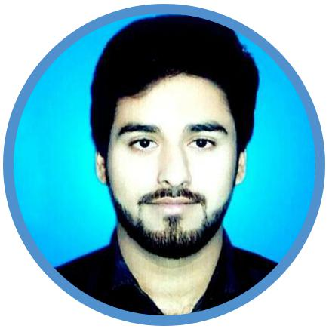

Bachelor of Engineering
(Mining Engineering)

zuhaibshaikh96@gmail.com

+923331220592

Sukkur, Pakistan

zuhaib-shaikh-52a07a52

zuhaib.shaikh82

PERSONAL INFORMATION
- Father’s Name : Zubair Ahmed Shaikh
- CNIC : 45501-5469393-9
- Date of Birth : 20-09-1996

WORK EXPERIENCE

Fresh / Entry Level

EDUCATION

DEGREE / LEVEL | BOARD / UNIVERSITY | YEAR OF COMPLETION | PERCENTAGE / CGPA
Matriculation | Board of Intermediate and Secondary Education, Sukkur | 2012 | 81.8%
Intermediate | Board of Intermediate and Secondary Education, Sukkur | 2014 | 76.27%
Bachelor of Engineering (Mining Engineering) | Mehran University of Engineering and Technology, Jamshoro | 2018 | 3.8/4

FINAL YEAR PROJECT

TITLE | SUPERVISOR | ROLE
Correlation between Uniaxial Compressive Stength and Point Load Index Strength of Thar Coalfield Block 1 | Prof. Dr. Abdul Ghani Pathan | Group Leader

SKILLS
- Teamwork
- Public Speaking
- Decision Making
- Leadership
- Managing
- Designing

SOFT SKILLS
- MS Office
- Adobe Photoshop
- AutoCad
- Typing 30 WPM

INTERESTS
- Management
- Marketing

CERTIFICATES
- Participation in ‘Young Leaders Conference’ Organized by YSWA Khairpur
- Participation in Seminar on ‘GEOVIA Surpac’ Organized by MSME, Mehran UET Jamshoro
- Participation in Seminar on ‘Research Methodology’ Organized by MSME, Mehran UET Jamshoro
- Participation in ‘Personal Empowerment Symposium’ Organized by MSME, Mehran UET Jamshoro
- Participation in Event on ‘International Miners’ Day’ Organized by MSME, Mehran UET Jamshoro
- Participation in ‘2nd National Conference on Metallurgy and Materials’ Organized by Department of Metallurgy and Materials, Mehran UET, Jamshoro
- Participation in Seminar on ‘Professional Development of Mehran University Students’ Organized by MUISTD, Mehran UET, Jamshoro

AWARDS
- Talented Student Award awarded by Bazm-e-Sathi Student Society, Sukkur

SCHOLARSHIPS
- Merit Scholarship awarded by Mehran UET, Jamshoro for 3rd position in First Year of B.E
- Merit Scholarship awarded by Mehran UET, Jamshoro for 3rd position in Second Year of B.E

SPORTS
- Best Player Certificate in Cricket during ‘Sports Tournament 2010’ Organized by Cadet College, Pano Akil
- Participated as Player in Tug of War during ‘Sports Week 2018’ Organized by MSME, Mehran UET Jamshoro

ORGANIZATIONS
ROLE | ORGANIZATION | PERIOD
Information Secretary | Mehranian Society of Mining and Exploration | Jan 2016-Sept 2016
Treasurer | Mehranian Society of Mining and Exploration | Dec 2016-Aug 2017
President | Mehranian Society of Mining and Exploration | Sept 2017-Aug 2018

VOLUNTEER
- Participated as Volunteer in Medical Camp during ‘Big Event 2017’ Organized by Mehran UET,Jamshoro

LANGUAGES
- English
- Urdu
- Sindhi

REFERENCES

Available upon Request

