SAAD ASHRAF SHAH
ABOUT ME

I have always proven myself with distinction and have the vision to excel in any work requirements of organization.

CAREER OBJECTIVE

I have good communication skills and am able to maintain good inter personal relationship. Have excellence planning, Organizational and interpersonal skills. Highly organized and dedicated with positive attitude. Self-motivated, responsible, creative, flexible and able to work independently and as a team member.

EDUCATIONAL VITALITY

Matriculation: Science Year of Passing: 2009

Board: B.I.S.E, D.G. Khan.
Institution : PAEC Model High School, D.G. Khan.
Division: 1st

Intermediate: DAE (Electrical) Year of Passing: 2017

Board: P.B.T.E (LAHORE)
Institution : SIT D.G. Khan.
Division: 1st
TRAININGS

03 Months RSTI Course from National Highway & Motorway Police.

01 Year Electrical Trainee Course (Continue) from NFC Multan.

EXPERIENCES

Fresh.

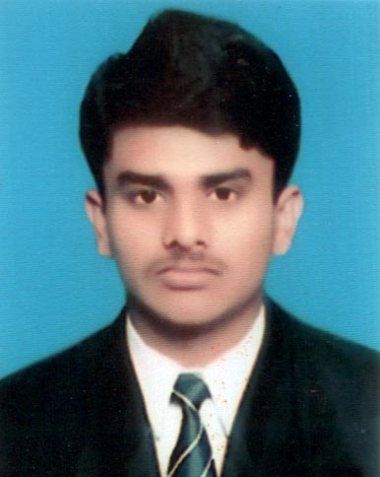

CONTACT INFORMATION
ADDRESS: House# D-226, St. 55, PAEC ECHS Rawat Islamabad.
CELL:
+92 321 6792236
Email
Saadcpc1@gmail.com

PERSONAL INFORMATION
Father’s Name: Muhammad Ashraf Shah
NATIONALITY: Pakistani
CNIC: 32102-2329476-3
RELIGIOUS: Islam
MARTIAL STATUS: Single
DATE OF BIRTH: 19-08-1991

SKILLS
Organizational Skills:
Negotiation

Time Management

Presentation

Communication

Project Management

IT Skills:
MS Office

Backup Management

Typing (40 WPM)

Social Skills:
Ability to communicate

Motivates

Inspire

Building Trust

Languages
English, Urdu, Saraiki, Punjabi.

