USAMA UMAR
Objective:
Seeking a challenging position in a progressive organization with an aim to contribute positively towards the achievements to the best of my capabilities. And to develop my skills that prides itself in giving substantial responsibility to new talent.

Qualification:

- BS in Mechanical Engineering (2014-2018) CGPA 3.55/4.00
International Islamic University Islamabad.

- FSc. Pre-Engineering (FBISE) (2012-2014) 788/1100
Islamabad Model College for Boys F7/3 Islamabad

- Matriculation (FBISE) (2010-2012) 802/1050
Islamabad Model College for Boys F7/3 Islamabad.

Final Year Project:
- “Simulation of Residual Stresses in Casting”

Fields of Interest:
- Simulation Software’s, CAD, Automobile, RAC, Industrial Management,

Workshops & Participations:
- Design and fabrication of a HUMAN POWERED HYBRID VEHICLE. (A project entered in a competition at NUST)
- Automated mechanical apparatus through Arduino.

Leadership Skills:
- Organizer of major events held at DME IIUI.
- Organizer of gaming event MECH’X at DME IIUI.
- Usher at 2nd International Conference PGSRET-2015.

Technical Skills:
- ANSYS (14.5, 15.0, 18.2), Pro-E (Creo, Wildfire), MS Office, MATLAB, Workshop and Machine-shop Experience.
Experience:
- Worked as an Internee in National Institute of Health Islamabad
W.e.f 17th July, 2016 – 25th August, 2016

Extra-Curricular Activities:

- Reading Books/Novels
- Watching documentaries/Series
- Cricket
- Football
References:
References will be furnished on demand.

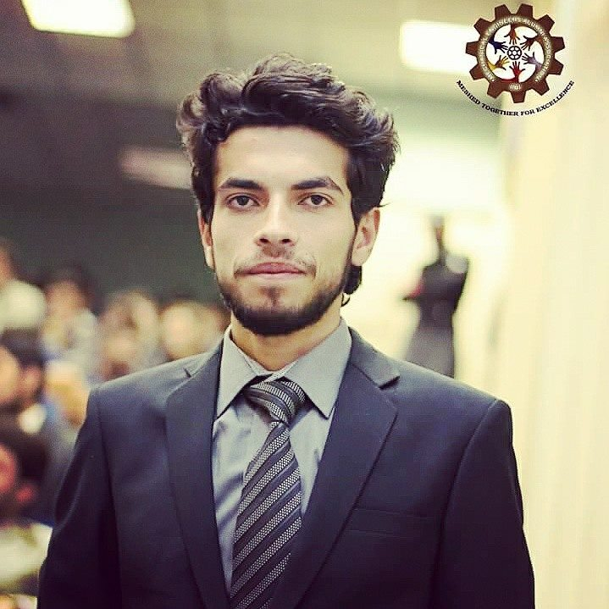


Javed Iqbal


17/09/1996


0092 303-5910802


61101-2293775-1

House Number F17 National
Institute of Health Colony
Islamabad

House Number F17 National
Institute of Health Colony
Islamabad.


Usamaumar424@gmail.com
Additional Information:


Single


Islamabad


Pakistan

ACHIEVEMENTS:

- Organizer at DME Open House 2015 at IIUI.
- Member of the Runner up Cricket team at DME cricket Tournament IIUI, 2016.
- Was Member of DME Futsal Team.

