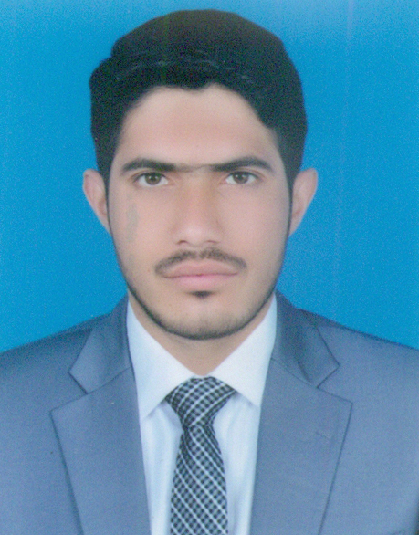
ZESHAN ASKRI
Address: Basti Gola Moza Sheikh Abdul Sattar
P/O Kotla Pathan Tehsil Khanewal District RY Khan.
Cell: 0305-3690539
Email: zeshanaskri007@gmail.com
Objective

To work to the best of my abilities in an environment that facilitates learning and encourages good performance.
Personal Profile

- Father’s Name : Zafar Hussain
- Date of Birth : 15-01-1998
- CNIC : 31301-0116258-3
- Domicile : RY Khan (Punjab)
- Religion : Islam
- Marital Status : Single
- Nationality : Pakistani
- Language : Urdu, English
Academic Qualification

Degree/Certificate | Year | Marks | Board / University
Matric | 2013 | 803/1050 | BISE Bahwalpur
D.A.E (Chemical) | 2016 | 2689/3400 | PBTE Lahore

Experience

- Fresh
Computer Skills

- Basic Knowledge of Computer
- Internet & Email

.Personal Skills

- Hardworking
- Quick Lerner

Reference

- Will be furnished on demand.

