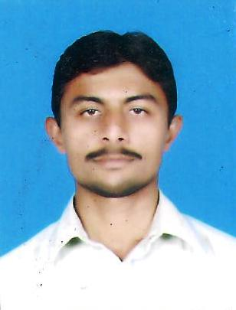
Mazhar Iqbal
Current Address: AVT CHANNELS, STREET#14, PLOT#90,I-9/2
ISLAMABAD-PAKISTAN.
Permanent Address: Chak # 5-WB, Tehsil & District Vehari.
Email: mazhariqbaljut786@gmail.com
Mobile # 0331-5513107
#03089123495
OBJECTIVE:

Wish to join an organization that can recognize my potential and provide me with the necessary training and expertise to help me progress further in my concerned field as well as help in building my confidence to pace with this innovative and challenging world.

PERSONAL PROFILE:

- Fathers Name : Zafar Iqbal
- Date of birth : 18/02/1994
- Nationality : Pakistani
- Domicile : Punjab
- Marital Status : Single
- Religion : Islam
- CNIC # : 36603-0747097-3
- Languages : English, Urdu, Punjabi

EDUCATIONAL QUALIFICATION:

- Diploma of Associate Engineer in Electronic, P.B.T.E (2014) with 1st Division (2339/3400).
- Matriculation (Science) from B.I.S.E Multan (2010) with 2nd Division (608/1050).

WORKING EXPERIENCE:

- 06 Month Experience as a TPI (Tripple Play Installer) In PTCL Rawalpindi.
- 03 year experience as a Electrician in avt channels pvt ltd Islamabad.

PROFESSIONAL COURSE:

- Successfully Completed 6 Months Diploma/Training from National Training Bureau (NTB) Islamabad in Optic Fiber Cable & Systems which covers the followings.
- Fiber Optical Cable Lying/Installation.
- FOC Splicing.
- Testing of FOC using (OTDR, Power Meter, Light Source)
- PDH/SDH Transmission Systems.
- DWDM

- Successfully Completed 6 Months Computer Course from PBTE Lahore.
- World
- Excel
- PowerPoint
INTERNSHIP: (Pakistan Telecommunication Company Ltd.

- Successfully Completed 6 Months Internship / Training from PTCL as following.
- Internship under RGM PTCL Islamabad.
- Knowledge about PTCL infrastructure and Networks.
- Basics OSP (Out Side Plant)/OFAN (Optical Fiber Access Network).GPON/FTTH.
- Installation / Troubleshooting of Triple Play services HIS. IPTV, POTS.
- Knowledge about Products and Services offered by PTCL.
- Played a role as member of operational Team working.
SKILLS:

- Good understanding of Windows OS, MS-Office, Email, Web Surfing, Searching, etc. provide me with an edge of correspondence and record keeping.
- Strong problem management, troubleshooting and analytical skills.
- Ability to communicate effectively with various internal and external teams.
- Independent works with excellent time management and escalation skills.

REFERENCES:

- Will be furnished upon request.

