ABDUL MUNEEB
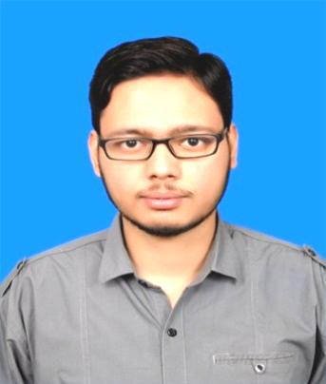
9TH MAY 1992, PAKISTAN
BS-CHEMICAL

Mobile:

Home:

PEC #:

Email:

Address:

+(92)3164141299

+(92)3095058008

CHEM/13604

abdulmuneeb9153@gmail.com

House no P-1013-B, Mohallah Anget Pura, Asghar
Mall Road, Rawalpindi

OBJECTIVE

I want to achieve professional and technical excellence in the field of Chemical Engineering through sincerity and hard work in a reputed organization that provides a promising career progression.

SPECIALIZATION

• Petroleum Refinery Engineering

• Polymer Engineering

• Industrial Energy Systems

PROFESSIONAL DEVELOPMENT
Murree Brewery Company Ltd. | From April 2017 to onwards

Key Processes, Operations and Training
- Distillation
- Heat Exchangers
- Cooling Towers
- Compressors
- Boilers
- Bio Gas Plant
- Pumps and valves

Job Title
1-Quality Control Officer

Responsibilities

Responsible for implementing Quality Standards at production lines
To test the samples after every 45mins taken from the production lines
Take appropriate measures to ensure consistency in product quality and provide solutions to improve the product quality
To perform raw material analysis i.e. % moisture test (barley), sieves tests, Molasses test etc

Make the quality report of the production during the whole shift

2- Batch Room(Syrup Room) Supervisor

Responsibilities

- To supervise the process of batch room and to ensure the Chemical dosages and quality parameters i.e. PH, Brix, Color, flavor according to given standards.
- To ensure and maintain PH, Hardness, Dissolved oxygen and TDS of mixing water within range.
- To ensure the desired amount of mixing water in stock prior to batch preparation.
- To plan RO plants maintenance.
- To pan the replacement of filtration sheets.
- To keep the record of Chemicals, Raw Materials and SPD(Store Purchase Demand) these things as required
- To filter the final product and transfer it to the final storage tanks.
- To keep the hygienic environment.
- To make batch manufacturing report.
3-Spirit Storage and Blending Room Supervisor

Responsibilities
- To blend R-OH and water under my supervision and make the desired R-OH% concentration.
- To add ingredients i.e. color, flavor and essence in mixture after ensuring the proper stay.
- To ensure the proper cleanliness of the storage tanks.
- To make the blending report.

Paramount Flow Technology International | From Oct-2015 to March-2016
Job Title: Sales And Service Engineer

RESPONSIBILITIES

- To visit the clients after every week and make technical report of boiler and/or cooling water chemicals.

- To maintain the key factors of boiler and cooling water chemicals and to rectify the problems and give proper solution

- To achieve sales targets

Brothers Sugar Mills Limited Chunian | 3 Months
Job Title: Internship

The purpose of this internship was to
To get the complete understanding of the chemical process of the plant

To ensure optimize & smooth plant operation under the supervision of senior chemists and process engineers.

To learn the functioning of different houses like Boiler House, Process House, Mill House and Boiling House of the chemical Plant
To learn maintenance scheme in schedule shutdown

Professional training

TECHNICAL SKILLS

• Maintenance Engineering and safety |  | • | Report Writing
• | MATLAB | • Competent in MS Office
• | AutoCAD | • | Programming C++

ACHIEVEMENTS

CPD short course on “Nuclear Waste Management” (certified)

Awarded with 26% fee waiving merit based scholarship in 2nd semester of BS(Chemical Engineering)
Awarded with 22% fee waiving merit based scholarship in 3rd semester of BS(Chemical Engineering)

Awarded with 43% fee waiving merit based interest free loan in 5th semester of BS(Chemical Engineering)

Projects

Production of formalin from methanol

Nickel recovery from spent batteries

ACADEMIC BACKGROUND
BS-Chemical Comsats Institute of Information Technology, Lahore, Pakistan
Fsc (Pre Engineering)Government College Asghar Mall RWP, Pakistan
Matric Manaar Public School, Rawalpindi, Pakistan

LANGUAGE SKILLS

Language | Read | Write | Speak
English | Fluent | Fluent | Fluent
Urdu | Advanced | Advanced | Advanced

EXTRACURRICULAR ACTIVITIES

• Cricket • Volleyball • Internet Surfing

