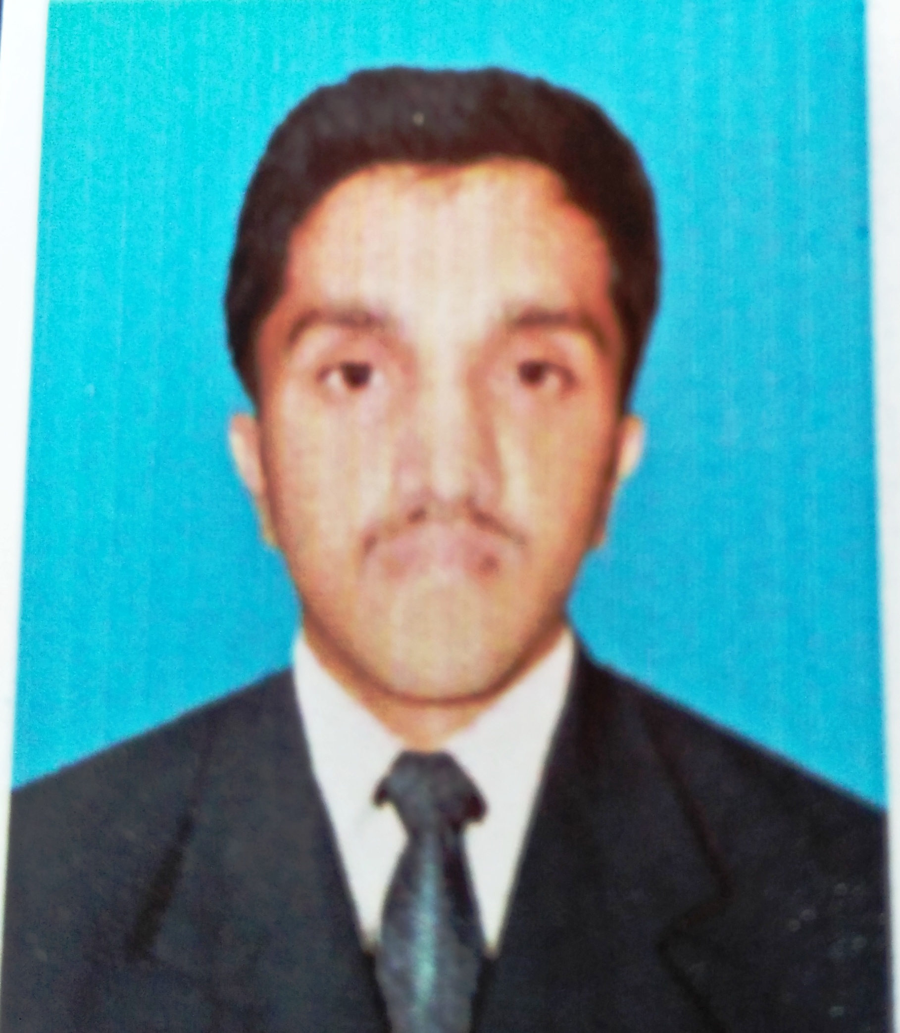

MUHAMMAD ARSALAN AKRAM
- Cell : 03495581172
- Address : Gond Pur P/O Gondpur Teh: Bhera, Distt: Sargodha.
- Date of Birth : 20-05-1998
OBJECTIVES:

  - To work in the dynamic, team oriented and co-operative environment where there is maximum chance enhancing and providing expertise. Eager for working as individually as well as team member. Always be willing to prove my skills and abilities.
PERSONAL INFORMATION:
- Father’s Name : Muhammad Akram
- Martial Status : Male
- Nationality : Pakistani
- Religion : Islam
- Domicile : Sargodha (Punjab)
- Languages : Urdu, English, Punjabi
- CNIC : 42201-6163779-7
ACADEMIC QUALITIES

Level | Year of  Passing | Total marks | Obtain marks | Percentage% | Board / University
Matric | 2014 | 850 | 544 | 64% | Karachi Board
D.A.E | 2018 | 3550 | 2882 | 81% | Punjab Bord Of Technical Education Lahore

ABOUT ME

- Self motivated and target oriented.
- Hardworking, efficient and proficient.
- Reliable and responsible work ethics.

