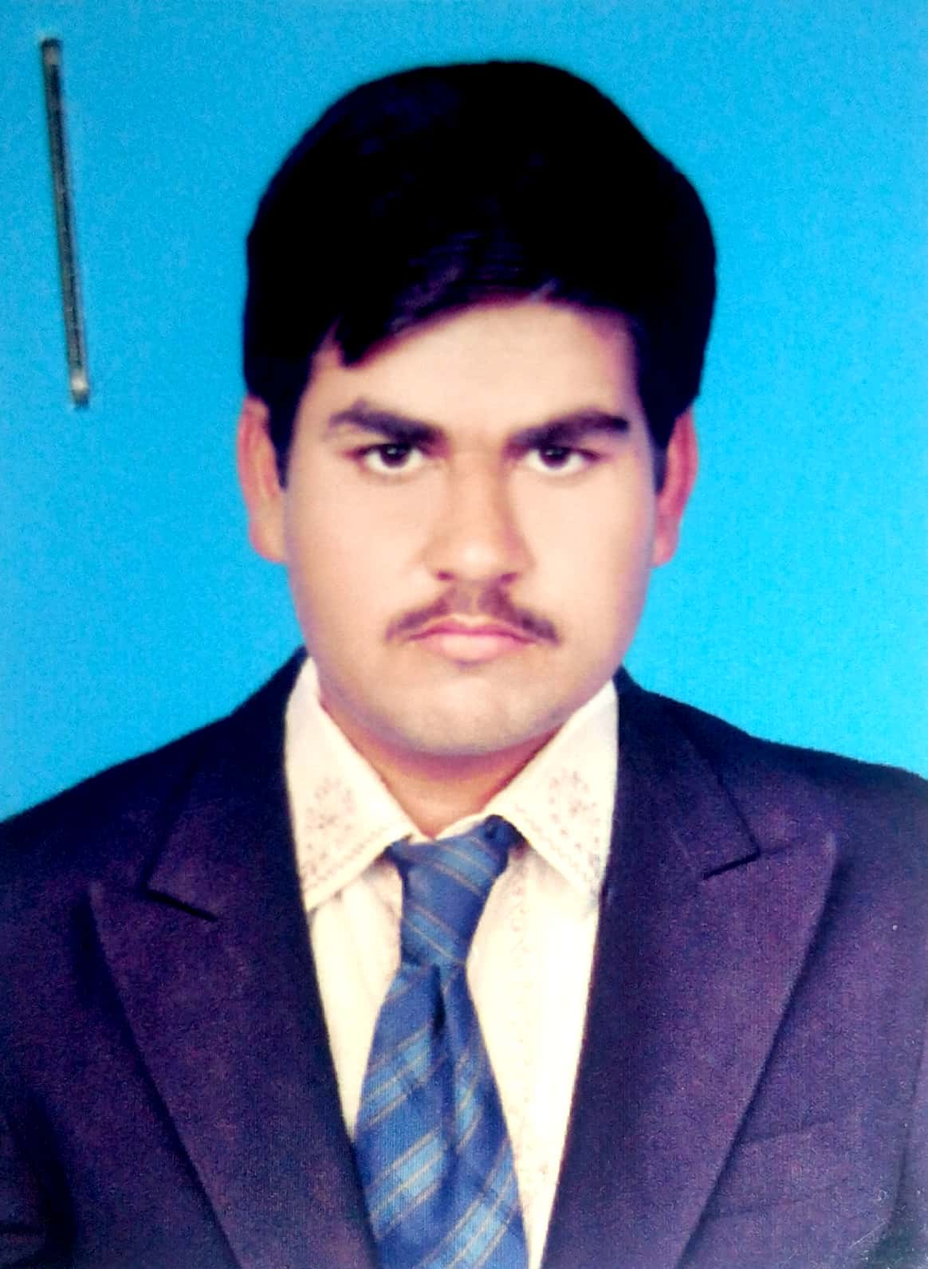

Shahzad Ali
Chak no 50/P Post Office Chak no 51/P
Tehsil and District Rahim Yar Khan
Mobile: 0304-8700749
e-mail: chshahzadali175@gmail.com

PERSONAL PROFILE

Name: Shahzad Ali
Father Name: Atta Ullah
Mobile: 0304-8700749
E-mail: chshahzadali175@gmail.com
Date of Birth: 15th June,1995
Marital Status: Single
Nationality: Pakistani
Address: Chak no 50/P Post Office Chak no 51/P
Tehsil and District Rahim Yar Khan

OBJECTIVE
To seek up-to-date knowledge and gain practical experience for today's competitive environment and apply to the best of my skills.As an individual gain professional experience and utilize my maximum skills

EDUCATION

Education | Institute | Marks | Division | Year | Board
Matric | Govt High School Chak no 51/P | 596/1050  (56.7%) | 2nd | 2010 | Bahawalpur
Intermediate  (I.com) | MTB College Rahim Yar Khan | 657/1100  (59.7%) | 2nd | 2012 | Bahawalpur
DAE Mechanical | RCT College Rahim Yar Khan | 2819/3450  (81.7%) | 1st | 2016 | Punjab Board Of Technical Education

TRAINING/WORKSHOPS/SEMINARS
- CIT Computer Course

WORK EXPERIENCE
- Having experience of one year in textile industry

SPECIAL SKILLS/ABILITIES
- Microsoft Office
- Hard Working
- Challenging

