ADNAN MEHMOOD  O B J E C T I V E |  | 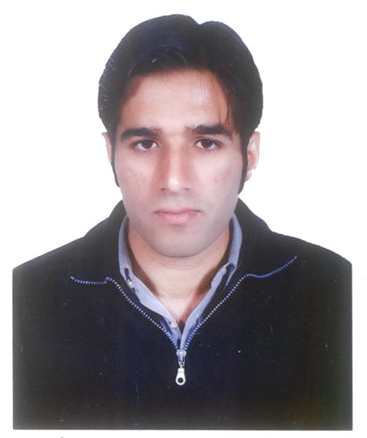  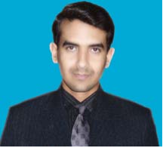
Seeking a challenging role in a dynamic organization, where I can contribute for the growth
of the institution and my professional technical development.

E D U C A T I O N
2005-2009 B.Sc Electrical Engineering (Electronics)
CGPA 3.22/4.00
Grade/Division 1st Division
University FUUAST , ISLAMABAD (Accredited by PEC)

2002-2004 HSSC
Grade/Division 2nd Division
Institute/Board Board of Intermediate & Secondary Education Rawalpindi

2000-2002 SSC
Grade/Division 1st Division
Institute/Board Board of Intermediate & Secondary Education Rawalpindi

C O M P U T E R S K I L L S

Office Suite
Microsoft Word Microsoft Excel Microsoft PowerPoint
Platform
Microsoft Windows Microsoft Window’s XP
CASE Tools
AutoCAD
Erp
Electronic Workbench
Programming Language C/C++
MATLAB

M A J O R A C A D E M I C C O U R S E S

- Business Communication
- Communication System I & II
- Digital Signal Processing
- Digital Electronics
- Information theory & Communication System
- Optoelectronics
- Power Electronics
- Microprocessor & Microcontrollers
- Electronic Devices and Circuits
- Measuring Instruments
- Power Electronics
- Electric Machines
- Industrial Electronics
- Electrical Circuit
- Digital Logic Design
- VLSI System Design
- Signal and system
- Micro Controller
- Filter design

E X P E R I E N C E 1

Organization Aalco group of companies Doha-Qatar
Designation Site Engineer(Electrical)
Department Aalco construction Division
Type of job Contract Base
Duration 27 Apr 2014 to 11-Dec 2016
Project name Electrical Distribution Networks

Responsibilities

- Collect the drawings
- Visits the site and arrange materials
- Check for the safety Requirements
- Trench excavation for HV/LV cable installation
- HV/LV cables laying works
- Checking continuity for the installed cables
- Coordinate with QA/QC inspectors
- Coordinate with the team workers
- Backfilling and reinstatement work
- Concreting and asphalting work
- Make the site ready before shutdown

E X P E R I E N C E 2

Organization Berri gas plant jubail Saudi aramco –saudi arabia
Designation Foreman
Department Maintenance
Type of job Contract Base
Duration 5 may 2012 to 10 dec 2012(7 months)
Project name Generals

Responsibilities

- Open work permits
- Arrange safety for the site
- Shut down for gas turbine
- Concreting and asphalting work
- Usage of Electronics Equipments
- Installation of MEP Conduits
- Installation of Electrical Cables
- Coordinates with the safety and QC inspectors
- Coordinate with team workers
- Cad Welding For grounding cables (70mm,35mm)

E X P E R I E N C E 3
Organization Saudi Aramco saudia Arabia,Madina
Designation Site foreman(electrical)
Department Piping & Instrumentation
Type of job Contract Base
Duration 15 Jan 2011 to 31-april 2012
Project name Replacement of Turbine controllers

Responsibilities

- Open work permits
- Visits the site to start the world
- Arrange the safety for the site
- Coordinate with the safety and QA/QC inspectors
- Coordinate with team workers
- Installation of Electrical & Mechanical Conduits(MEP)
- Usage of electrical and electronics equipments.
- Trench excavation for Foc cable installation
- Installation of fire alarm for control vans
- Installation of FCv for turbines
- Installation of pedestals for Foc Cables
- Installation of DMc for UCP
- Concreting and asphalting
- Cad Welding For grounding cables (120mm,70mm,35mm)

E X P E R I E N C E 4

Organization Works and services Chakwal Pakistan
Designation Trainee engineer
Department Buildings Devision
Type of job Contract Base
Duration 10 Jan 2010 to 20 Oct 2010(10 months)
Project name Schools and colleges

Responsibilities

- Installation of Electrical wiring
- Usage of electronics Equipments using.
- Estimate for electrical equipments
- Installation of electrical cables
- Concreting and asphalting work
- Piping and conduit works

E X T R A C E R T I F I C A T E S

- Saudi aramco certified work permit receiver for EWPL (2011 to 2013)
- Saudi aramco certified work permit receiver for BGP (2012 to 2014)
- Safety orientation for EWPL
- Safety orientation for BGP

F I N A L Y E A R P R O J E C T
Secure Communication By Using Frequency Hopping Spread spectrum (FHSS)
The main theme of the project is to develop a transmitter and receiver for secure communication using a technique of frequency hopping spread spectrum (FSHH).This device have the capability of sending secure voice signals to our specific receive.

P E R S O N A L I N F O R M A T I O N
- Father’s Name: Khalid Mehmood ~ Marital Status: Single
- Date Of Birth: 25 june 1987 ~ Nationality: Pakistani
- Domicile: Punjab ~ N.I.C. Number : 37201-6352447-7
C O N T A C T I N F O R M A T I O N
Postal address Phone No:
Khalid Mehmood, Cell : +92 - 0333-5901726

House # MCB-1/1386,Dhakoo Road, E-Mail:
Mohallah chistian,Chakwal bravopakistani01@gmail.com

Skype ID :
Bravo_sa

I N T E R E ST
- Surfing the internet.
- Playing Cricket

