URRICULUM ITAE

Adnan Khan
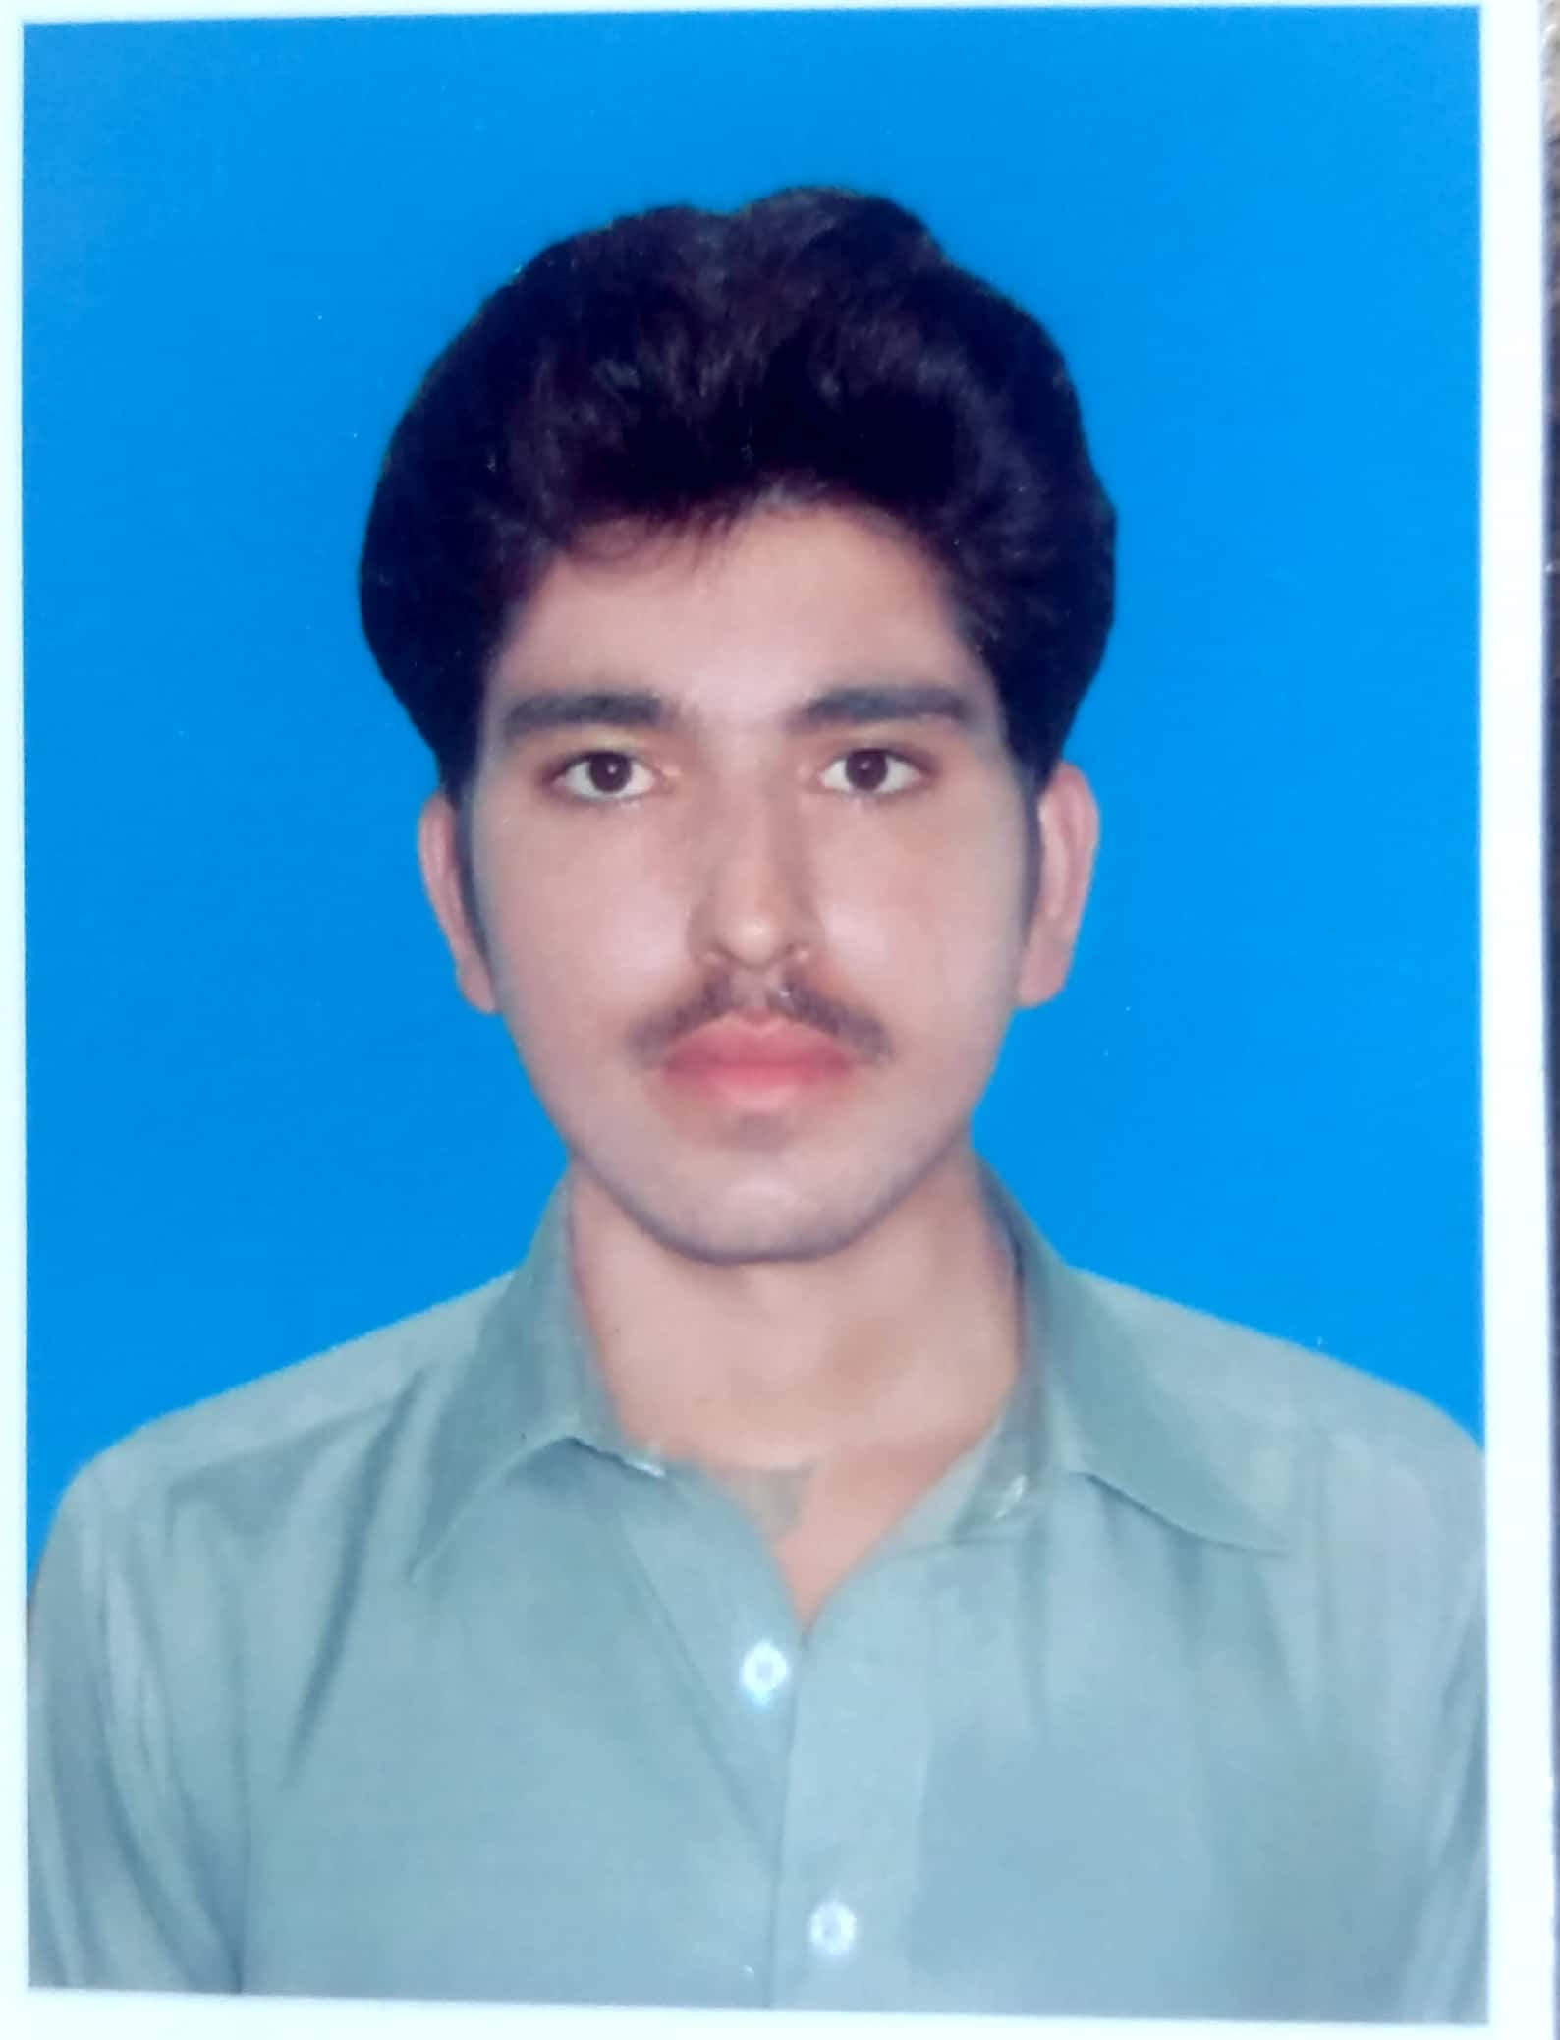

Postal Address: Vill: kotka painda Mir Kala P/O Domel
a Distt Bannu

Contact No :03048919574

Email: Adnanwazir628@gmail.com

Personal Profile
Father’s Name : Hakim Khan
Domicile : Distt Bannu
Date of Birth : 14/03/1999
Nationality : Pakistani
Sex : Male
Religion : Muslim
N.I.C No. : 11101-8103882-1
Marital Status : Unmarried

Academic Qualification
QUALIFICATION | Session |  | Marks | INSTITUTE
SSC | 2015 |  | 900/1100 | BISE Bannu
DAE | 2018 |  | 2671/3450 | BTE Peshawar

Languages Known

1: English
2: Urdu
3: Pashtu

