CURRICULUM VITAE

Muhammad Taqi Jawad

Address

Vpo Thirpal Tehsil and Distt Chakwal

Date of Birth

29-11-1998

Language

- English
- Urdu
- Punjabi

Software Skills

- Basic Computer Skills
- Internet

Personality

- Optometric
- Patent
- Creative
- Communicative

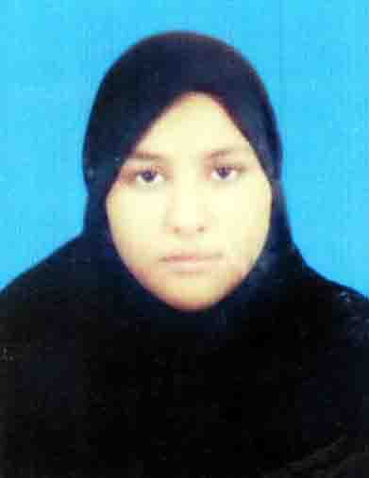
Career Objective:

To enhance my abilities in a very professional way I would like to be a part of a Professional team to work in a challenging and professional environment with maximum opportunities for career growth and development.
Personal Profile:

- Father’s Name : Ansar Hussain
- Nationality : Pakistani.
- Religion : Islam.
- CNIC : 37201-2404420-7
- Gender : Male
- Martial Status : Single

Contact

- Contact No. : +92-336-5141406
- Domicile : Chakwal - Punjab

Academic Qualification:
Degree Title | Passing Year | Marks Detail | Board
Matric (Science) | 2015 | 633 / 1100 | BISE Rawalpindi
D.A.E (Electrical) | 2018 | 2913 / 3550 | PBTE Lahore

Projects:

LIGHT DEPENDENT RESISTOR
- It’s a resistor which automatically turns on and off the hub.
12V REGULATED POWER SUPPLY
- It converts 220V AC Supply to DC supply using 15V transformer.

Reference:

- Will be furnished on demand.

