PERSONAL INFORMATION | M Asad ur Rehman
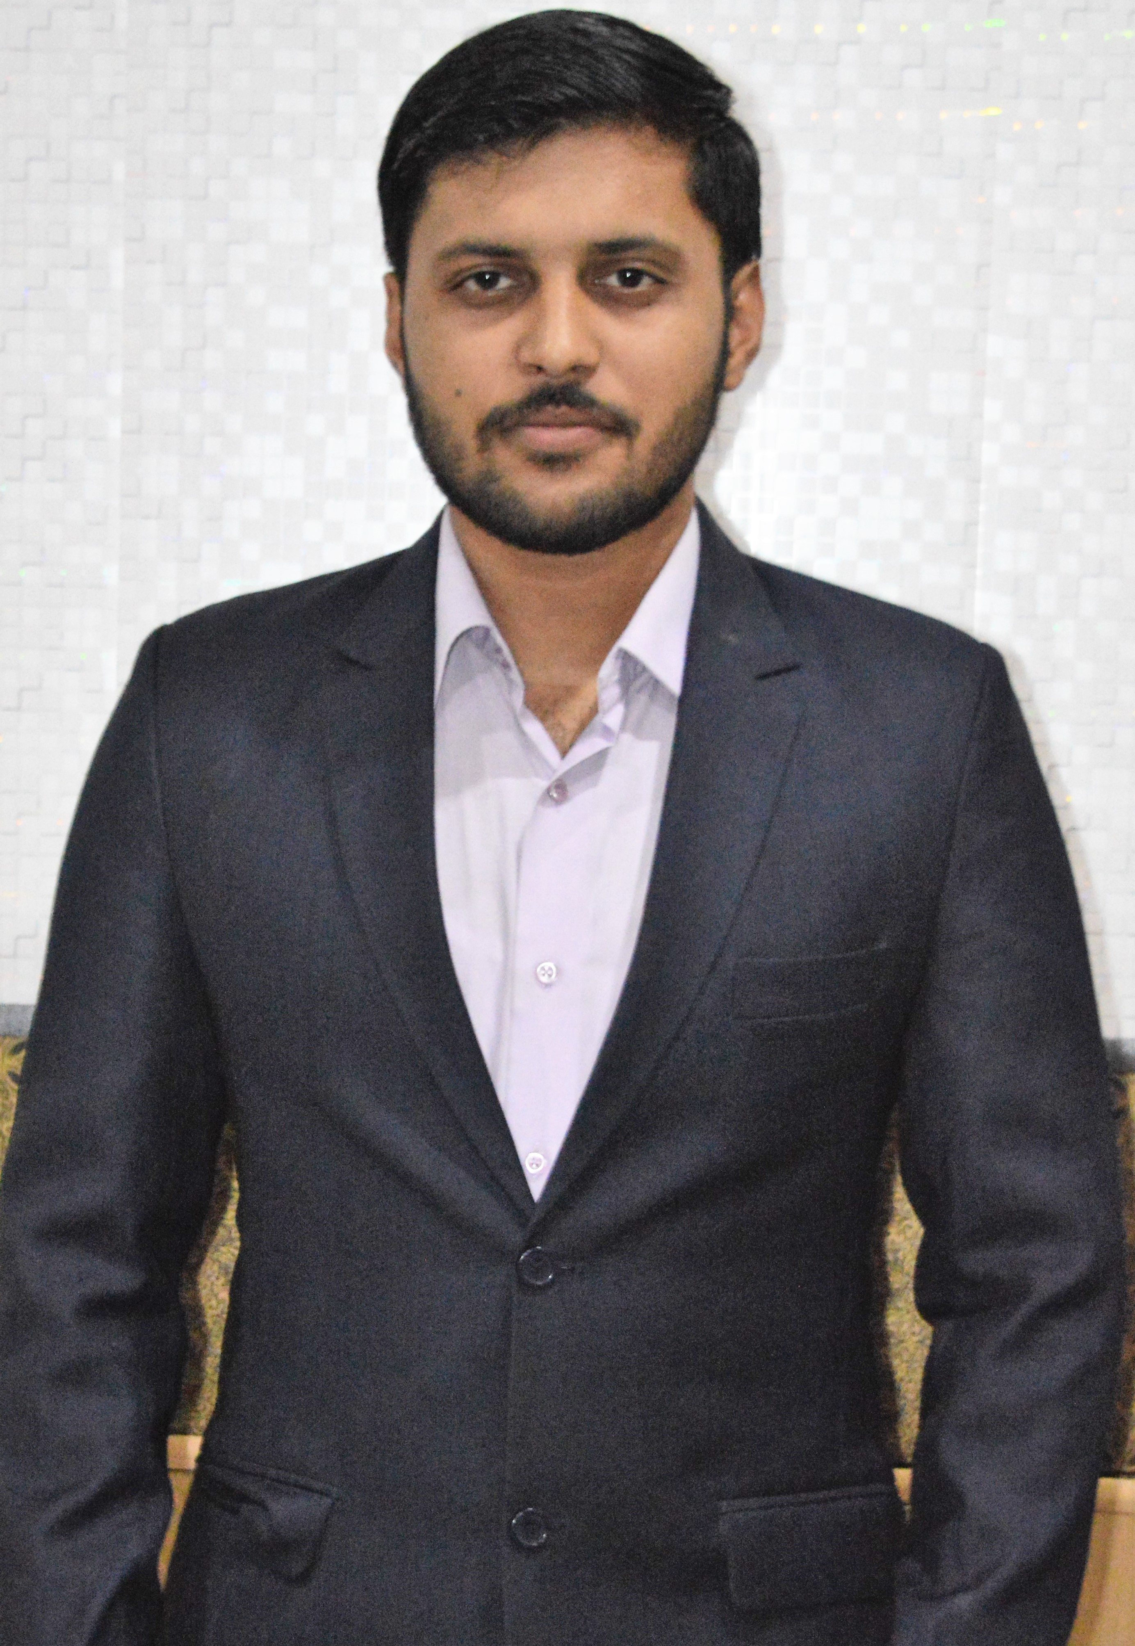 |   H# 92-A Huma block Allama Iqbal town, Lahore
 |  +923003744448

Asadwahla92@yahoo.com
 | Sex Male | Date of birth 22/02/1995 | Nationality Pakistani

Looking towards a professional carrier with international research degree and experience.

WORK EXPERIENCE

01-08-2016 - 15-08-2016  14-02-2018 - Present | Trainee Engineer
01-08-2016 - 15-08-2016  14-02-2018 - Present | Millat Tractors Limited, Lahore, Pakistan.
01-08-2016 - 15-08-2016  14-02-2018 - Present | - Assistance in productivity and quality control of products.  - Maintenance of Machines (preventive maintenance).  Project Engineer  Elmec International Limited, Lahore, Pakistan.  - Research, design, fabricate, and install HVAC mechanical equipment to meet client’s requirements in both large and small projects.  - Consult on HVAC system and equipment design for a wide range of projects, and work with other engineers, project managers, and construction professionals as needed to create and/or modify design parameters.  - Performed responsibilities of providing engineering input in estimating equipment and assisted in material cost for successful project execution.

EDUCATION AND TRAINING

October 2013-2017 | Bachelor of Science in Mechanical Engineering | 2.64/4.0
October 2013-2017 | University of Central Punjab ( Lahore, Pakistan )
October 2013-2017 | Core subjects: , Fluid mechanics(I,II), Renewable energy technology, Refrigeration and air conditioning, Internal combustion engine, Power plants, Machine design, Mechanics of materials(I,II), auto cad and graphics, Industrial Electronics, Industrial materials, Thermodynamics.  Final Year Project Thesis: Design and Fabrication of lower-extremity exoskeleton.
June 2011-sep 2013 | Higher Secondary School Certificate (Pre-engineering)
June 2011-sep 2013 | Forman Christian College University ( Lahore, Pakistan )
June 2011-sep 2013 | Core subjects: Maths, Physics, Chemistry

PERSONAL SKILLS

Organisational / managerial skills | Communication, management and leadership skills gained through my experience as Marketing head of SME UCP and active member of other societies.  - Organised national level events as a head.  - Working as an internee developed technical problem solving skills and enhanced field knowledge.
Computer skills  Projects | Smooth Understanding with:  Design and analysis: Auto cad, Creo PTC, ANSYS (mech APDL), Solid works.  Programing: C++, Matlab, Aurdino.  Microsoft: Office, Word, PowerPoint.  - Design and fabrication of automated hacksaw using slider crank mechanism.  - Design and fabrication of Air Engine.  - Design and fabrication of Paper cutter.  - Design and fabrication of lower-extremity exoskeleton device (final year project and is awarded as best in annual exhibition).
Memberships | - Pakistan HVACR Society Lahore Chapter.  - BioMechatronics research group, University of Central Punjab, Lahore  Weblink: https://sites.google.com/view/ucp-bmct

Achievements and Awards | - Gold medal in Final Year Project.  - Gold medal in Egg Drop Competition.  - Runner up in truss bridge design and build competition at UCP.  - Awards from student council UCP for volunteer work in management and marketing.

Social participation | - Selected as a marketing head for society of mechanical engineers UCP.  - Arranged blood donation camps for blood donor society UCP.  - Volunteer work at Punjab cardiology hospital for rehabilitation of heart patients.  - Founder of HVACR student chapter UCP  - Member of HVACR student chapter UCP.  - Arranged seminar on HVAC systems at UCP in collaboration with HVACR society.  - Attended seminar on entrepreneurship by entrepreneurship club UCP.  - Attended and organised 13th international HVACR expo and conference.

ADDITIONAL INFORMATION

References | - Dr Zohaib Aftab (final year project supervisor )  University of Central Punjab, Lahore.  Email: dr.zohaib@ucp.edu.pk  - Muhammad Kashif (lecturer)  University of Central Punjab, Lahore.  Email: Muhammad.kashif@ucp.edu.pk

