QASIM KHAN

Moh: Garhi Khel,
Village & P.O: Kahi,
Tehsil & District Nowshera,
Khyber Pakhtunkhwa, Pakistan.

OBJECTIVE:

- Seeking a position in a high caliber organization that will enable me to gain additional experience on the job that further enhances my knowledge and skills.

PERSONAL DATA:

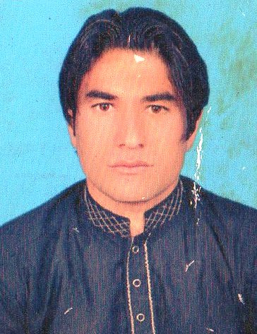

- Father’s Name : Muhammad Ibrahim
- Date of Birth : 10-04-1998
- Gender : Male
- NIC # : 17201-8896073-1
- Religion : Islam
- Nationality : Pakistani
- Domicile : District Nowshera (KPK)
- Marital status : Single
- Contact No. : +92-306-8551640
EDUCATION:

Certificate/Degree | Session | Obt:Marks/Total | Per% / Div / Grade | Board/University
Matric (Science) | 2014 | 638/1100 | 58/ 2nd / C | BISE Mardan
D.A.E (Electrical) | 2017 | 2253/3550 | 63.46 / 1st / B | KPBTE-Peshawar

COMPUTER SKILLS:

- Microsoft Windows
- Ms-Office
- Internet
- Windows and Software Installation

LANGUAGES:

- English
- Urdu
- Pashto

