Majid Islam
Contact: 0312-9398096
Address: Mohallah Toker Khel P.O Mattani Distt Peshawar

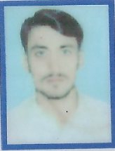
OBJECTIVE:
To work in a challenging environment in any government and non government organization for career growth through sincere, achievement and skill and where evaluation is based on performance and where is an equal chance of career development.

PERSONAL INFORMATION:
- Father’s Name : Islam Gul
- Nationality : Pakistani
- Domicile : Peshawar
- D.O.B : 20/03/1998
- Religion : Islam
- CNIC : 17301-0892106-7
- Gender : Male
- Marital Status : Single

EDUCATIONAL INFORMATION

Degree / Certificate | Marks | Passing Year | Board /University
S.S.C | 764/1050 | 2013 | BISE Peshawar
D.A.E (Chemical) | 2137/3400 | 2016 | KPBTE
MS Office | 286/300 | 2016 | Warsak Practical Survey Training Center Peshawar

Languages:

- English
- Urdu
- Pashtu.

