CONTACT INFORMATION:  Cell Phone # : +92-336-8774410  E-mail : naveedmehmood.ryk@gmail.com  Address : H. # 71Street No. 2 Rehman Colony  Thali Road, Rahim Yar Khan.  Punjab, Pakistan.  Postal Address : C/O Ghulam Shabbir  H.# 71 Street No. 2 Rehman Colony  Thali Road, Rahim Yar Khan.  Punjab, Pakistan. |  |  |  |  | 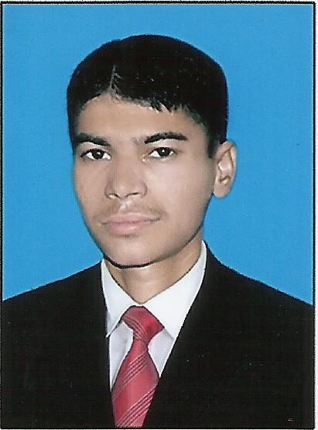
NAVEED MEHMOOD
Objective: To build my career in leading modern company and to prove myself in practical field, where I can participate to enhance the business of company by using my proven abilities.
PERSONAL POROFIL

Father Name : Ghulam Shabbir
CNIC # : 31303-3020026-7
Martial Status : Singal
Date of birth / Age : 07th January,1997
Motivation: Involved personally in Experience, Mistakes & goal sharing, resulting in increased productivity & business.

EDUCATION

Certificate /  Degree | Subjects | Division/  Grade | % age | Passing  Year | Board/  University
Diploma Of Associate Engineer (DAE) | MECHANICAL | 1st | 82 % | 2014 | PBTE Lahore
SSC | SCIENCE | 1st | 63 % | 2011 | BISE BWP
Skill: | Computer Literacy:  - MS Office.  - Computer basics.  - Internet.  Language:  - Urdu.  - English.
Interest: | - I am also a sportsman; my favourite game is cricket.

