ELECTRICAL ENGINEER
NOOR UL HUDA

 | 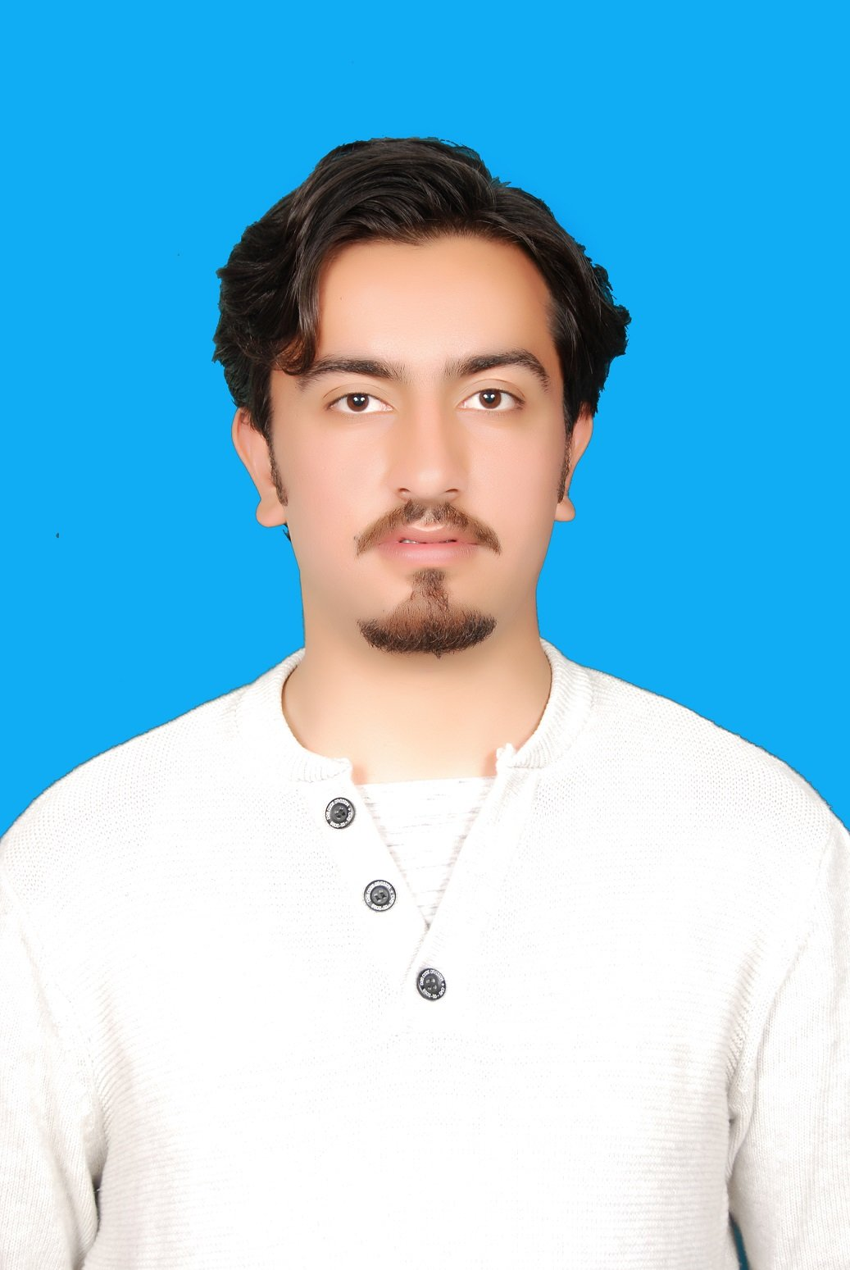 | Mailing Address : C/O Ashar Awan ,Kashmir Institute Of  Economics , University Of AJK City Campus  PEC No: 58673  Cell No. 00923439075888  Email: noorawan.11@gmail.com  Permanent Address C/O Muhammad Mussadiq Awan, near army supply, Chella  Chowk Muzaffarbad AJK .  Phone No.(Res) : 03008359538

PERSONAL PROFILE

Father Name: Muhammad Mussadiq Awan
Religion: Islam
Nationality: Pakistani (A.K)
CNIC. No. 82203-7656411-1
Date of Birth: 15th Dec , 1994

OBJECTIVES

To acquire a position in an effective and fervid organization, with an aim
to contribute positively towards the objectives of the organization to the best of my potential.

PERSONAL SKILLS
- Excellent Communication Skills.
- Self motivated , focused and dedicated.

AREAS OF INTREST
- Power Generation.
- Transmission and distribution.

EDUCATIONAL PROFILE

S.No | Qualification | Year | %age/CGPA | Institution
1 | B.Sc. Electrical  Engineering | 2016 | 2.8/4 | Mirpur University of Science And Technology Mirpur A.K
2 | F.Sc Pre  Engineering | 2012 | 737/1100 | Govt Model Science College  Muzaffarabad A.K
3 | Matriculation | 2010 | 658/1050 | FG Dawood Public School  Muzaffarabad A.K

MAJOR PROJECT

- Smart Load Management Of building between Line Voltage and Generator.

COMPUTER SKILLS
Operating Systems: Windows 7,8, xp, Vista, Macintosh, Ubuntu
Application packages: MS Office
Development Tools & Languages: , C, C++, Java, Lab view ,Mat lab, ETAP

INTERNSHIPS AND EXPERIENCES
- Worked as an Internee in Neelum Jhelum Hydropower Company (Pvt)Ltd
(A Subsidiary of WAPDA)

CERTIFICATIONS
- Active participation in speech competition at college level.
- Certificate of Participation in Airex 14 at GIKI .
- Participated in All Pakistan Football Tournament at school level.
- Winner Of Rawalpindi region Football Tournament.
- Active participation in Art and dramatic competitions.
- Worked as Coordinator of SDC (society) at University.

LANGUAGES

- Urdu, English ,Hindhko, Punjabi

Note:-All references and certificates will be provided on demand

