MUHAMMAD ASAD MALIK

Career Objective:

I wise to grow professionally through accepting greater Responsibilities.I will prefer to join multinational organization, Where I shell have the opportunity to enhance my professional status, enrich my outlook and ability to surmount into challenging environment.
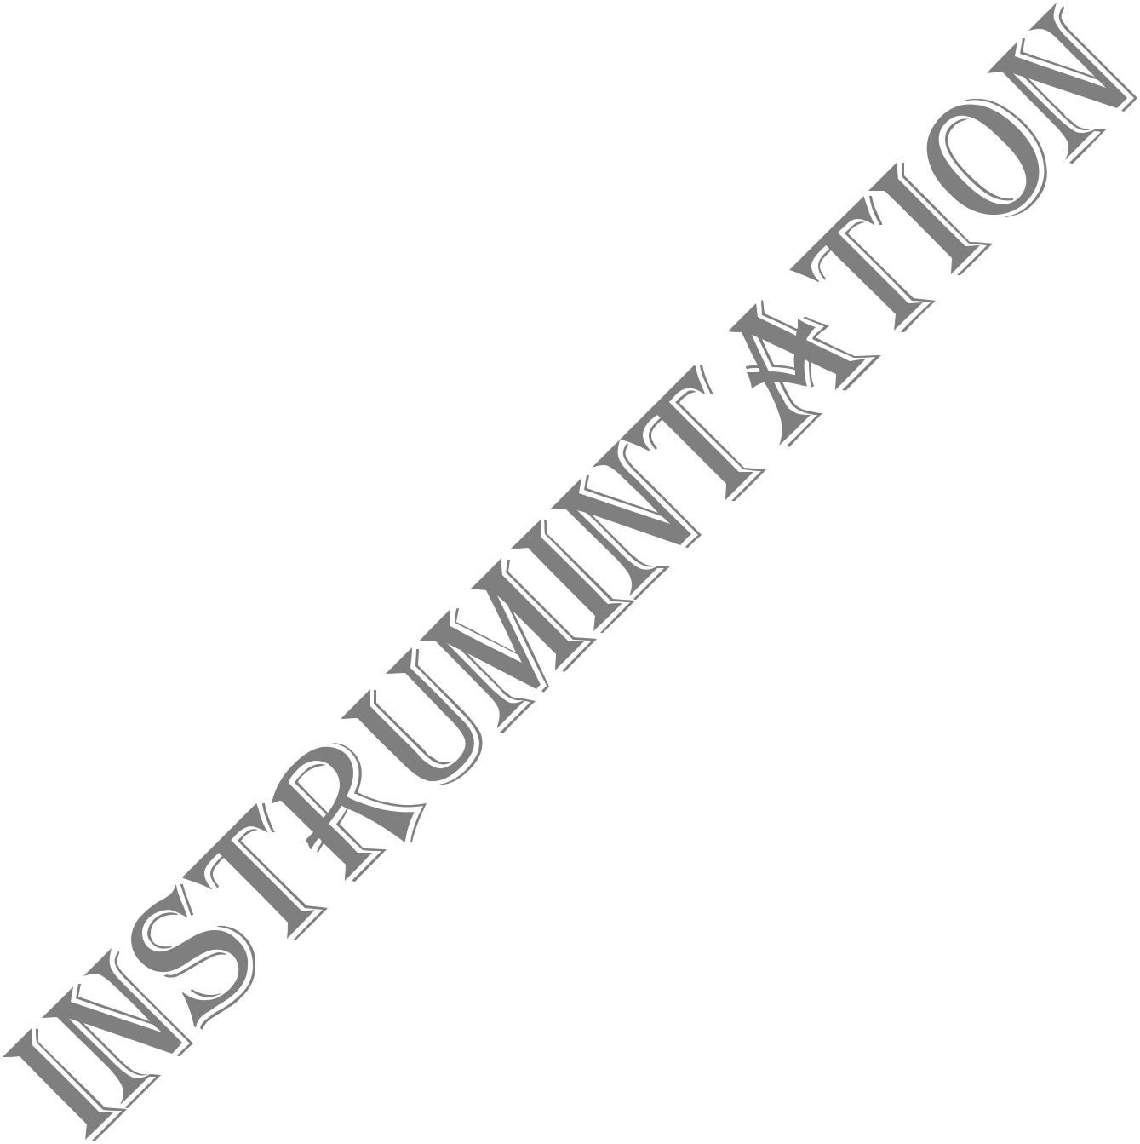
Personal Profiles:
Father`s Name : Malik Muried hussian
CNIC# : 38403-1156841-1
Date of Birth : 14-08-1995
Domicile : (Punjab)
District : Sargodha
Gender : Male
Marital Status : Single
Religion : Islam
Nationality : Pakistani
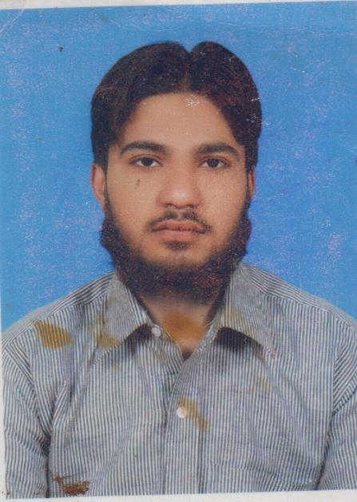

Academic Education:

- Diploma of Associate Engineer in Instrumentation from Govt

College of Technology Sargodha with 73.69 % marks.
- Matric Board Of Intermediate & Secondary Education,
Sargodha with 64% marks.

Collage Project :
I am perform the two types of project (Radiation

Payrometer & Digital automatic level and controller.

Experience:

I have 3 month experience in (Noon sugar mil balwal LTD ) as instrument technician
I have 3 month experience in ( Pakistan Atomic Energy Commission Mianwali ) as Instrument Technician
I have 2 year experience in (Electronic Shop in Sargodha) as Technician
I have 2 year experience in (University of Lahore Sargodha Campus ) As Lab Assistant

Permanent Address:
Contacts:
• Cell no # |  | 03057228260 - 03468629270
• E. mail: |  |  |  | asadmalik9541@gmail.com

Chak No. 46 NB Al Jallal town (VIP) House No 3Sargodha.

