Muhammad IBRAHIM
Postal Address:  Cell Phone:  E-mail: | Shop#147 New Boulton Market M A Jinnah Road  Karachi  03119881511 /03429175335  Ibrahii35@gmail.com | 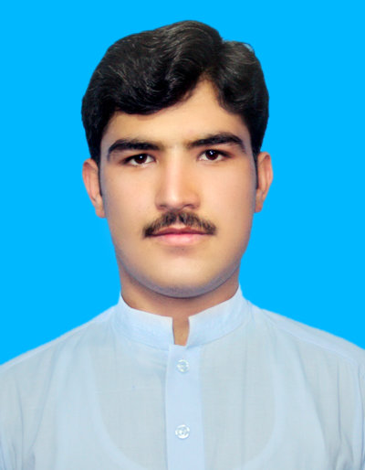

Personal profile
I am a young, enthusiastic, qualified, skilled, and self-motivated person with a strong interpersonal skills. I am capable of accepting challenges and wish to work in a highly competitive and growing environment.

OBJECTIVE
To pursue my professional career in a reputed, dynamic and prestigious organization which provides the opportunity to its employees to develop their skills in their respective fields; which instills in the employee a sense of commitment and motivation for the work being done.

Educational qualification
Graduated as a MECHANICAL ENGINEER from the UET PESHAWAR

Acadamic record
Certificate
Passing year | Obtained Marks | Total Marks | Percentage | Institute
BSc. Engineering | 2013-2017 | 3.29 | 4 | 82.25 | University of Engineering & Technology, Peshawar
HSSC  (FSc) | 2011-2013 | 956 | 1100 | 86.90 | Islamia College Peshawar
SSC (Matric) | 2009-2011 | 915 | 1050 | 87.14 | Ummathe wahida High School

Subject of interest
- Power Plant 2. Thermodynamics
3. Manufacturing process 4. Refrigeration and Air conditioning
5. Machine Design 6. Heat and Mass Transfer
7. Production Automation 8. Industrial Management

PROJECTS
- Modifying chair left system for Hydel power Generation
- Design and Fabrication of Reciprocating Saw
- Fabrication of Stress Strain Gauge

COMPUTER SKILLS
- Auto CAD(2D+3D)
- MS Office 2003/13

EXPERIENCE
- Working as HVAC Engineer in Eximpo Cool Chain, Star Mill.

LANGUAGES
- ENGLISH, PASHTO and URDU

Personal Data
Father’s Name: Dilawar Khan
NIC Number: 17301-2040656-9
Date of Birth 1th March, 1995
Domicile: Peshawar
Religion: Islam
Nationality: Pakistani

