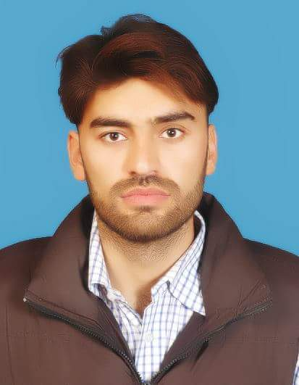

Contact # +92-3489619367
Email:eng.kalimkhan@gmail.com
Kalim Ullah

Career Objectives To pursue a challenging role in a truly global venture where worthy experience, professional skills and capabilities can be groomed and utilized for the benefits and growth of the organization.

EXPRERIENCE

BSS Engineer
Associate Technologies Pvt Limited(ATL) May 17 till Date
- Work on USF Telenor project kohistan

Reporting Engineer
LTH (JV) (New Benazir Bhutto International Airport Islamabad. Feb 2013 to Oct 2016

- Working as Electrical Engineer

Sub-Engineer.
Frontier Ceramics Ltd: Peshawar Pakistan Feb 2007 to May 2008
Peshawar Pakistan
- 1 year Internship Experience.
- Worked on Motors & Generators.
- Also worked as Sub-Engineer.

Major Projects:

- Air Power Plant.

Major Subjects:

- Electronic Circuit
- Power Plant
- Digital & Industrial Electronics
- AC & DC Machine
- Basic Electronics
- Principal of electrical engineering

EDUCATION

BE Telecom Power:
Numl University Dec, 2012
Islamabad Pakistan
DAE (Electrical)
Peshawar Institute of Information Technology Sep, 2008
Peshawar Pakistan
DIT
Joher Institute of Information Technology Oct, 2010
Islamabad Pakistan
Matric
Peshawar Board (Subjects: Science)

COMPUTER KNOWLEDGE

Advanced Diploma in Information Technology (ADIT)
- Windows 98,XP,Window 7
- M-S Office
- Internet Browsing
- Assembly Language Programming.

Personal Endeavors Easy going, team oriented, self starter, target oriented and very much energetic.

PERSONAL DETAILS
Religion : Islam F/Name : Tamoor Khan
Marital Status : Single Nationality : Pakistani
DOB : Sep, 1989 Availability : Immediate
Domicile : Peshawar
Speaking Skills : English,Urdu,Pashto
N.I.C : 17101-9359189-7

REFERENCES
References will be furnished upon request.

