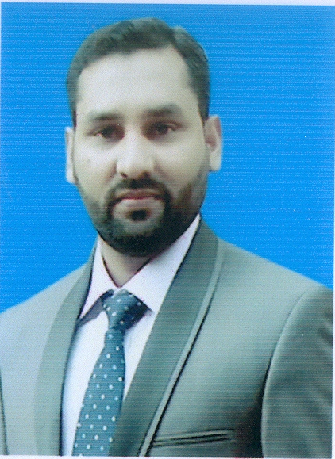
Qasim Ilyas S/o Hon Sub Maj.Muhammad Ilyas (Retd)
Domicile : Punjab (Gujranwala)
CNIC : 54401-2848537-1
Education : PGD (HRM), BA
Address : C/o Khattak Karyana Store, Mohallah, Chamanabad, Misrial Road Rawalpindi
DOB : 19 Feb 1988
0300-2945700 0321-5144531  qasim.ilyas786@gmail..com
OBJECTIVES

Craze to obtain a vibrant position in the field of HR/Administration to initiate a progressive career in soothing environment that support my growth toward professionalism where I want to be well acknowledged with dwelled tactical hands and develop more skills, keeping in view the requirement mentioned in my bio-data for your persuals and considerations.

EXPERIENCE

Designation | Organization | Duration
Human Resource Assistant | Askari Cement Limited,Nizampur, Pakistan | 02 Sep 2013 to date
Office Assistant Purchase | Askari Cement Limited, Wah, Pakistan | 09 Aug 2010 to 31 Aug 2013
Computer Operator | Irfan Enterprises, R.A Bazar, Rawalpindi, Pakistan | 1 Oct 2009 to 08 Aug 2010
Honorary Clerk | FG Chiltan Middle School, Quetta Cantt, Pakistan | 06 Jan 2009 to 10 Aug 2009
Honorary Clerk | in F.G Degree College, Quetta Cantt, Pakistan | 15 Sept 2008 to 05 Jan 2009
Casual Clerk | Combined Military Hospital (CMH), Quetta Cantt, Pakistan | 1 May 2006 to 31 Oct 2006
ACADEMICS & QUALIFICATIONS

- Niaz Commercial College Quetta, Pakistan
Short Hand 6 Months Course
(Session 2008)

- Computer Link (Affiliated with IIT)) – Quetta, Pakistan
Office Automation 3 Months Certification
(Session 2008)

- Professional Graduate Diploma (HRM)
Professional Skill Recognition Board, Islamabad
(Session: 2014-2016)
72%

- Allama Iqbal Open University, Islamabad Pakistan
Bachelor (Economics, Fundamental of Business, Auditing, Mass Communication, Marketing, Advertising)
(Session: 2010-2012)
57%

- Federal Board of Intermediate & secondary Education Isalamabad, Pakistan
FA
(Session: 2004-2006)
FG Degree College Quetta Cantt, Pakistan
53%

- Federal Board of Intermediate & secondary Education Isalamabad, Pakistan
Matric (Science)
(Session: 2002-2004)
48% (2nd division)
FG Technical High School, Tariqabad Rawalpindi Cantt, Pakistan

SKILLS & ABILITIES

- Strong knowledge of HR cases, filing & MS Excel based Record keeping
- Strong computer skills with a high degree of competency in MS Word, MS Excel & MS Power Point
- Flexibility, Problem Solving and Leadership skills
REFERENCES

Available and will be furnished upon request.
MAIN RESPONSIBILITIES AS (ASSISTANT HUMAN RESOURCE)

1. Filling & Record Keeping
a. Preparation of personal files for new joiners (both in soft and hard form)
b. Preparation of files for office records other than personal files (office orders and letters used for various cases)
2. Assistance to SO – (HR) in routine HR operations.
3. Assistant to SO – (HR) during Induction of all vacancies announced by ACL time to time.
4. To Assist SO – HR during checking of Performance Appraisals Officers & Staff (Officers 3 time in year and Staff 1 time in a year)
5. Compiling of data for ESSI cards Registration, Renewal & Correction (if required)
6. Compiling of data for revision in Medical (Health) Cards.
7. Compiling of data for Provident Fund Membership Cases.
8. Preparation of lists (Long listings) for various vacancies announced time to time.
9. Dak receiving and dispatching.
10. Maintaining / updating NRO’s (for Officers & Staff).
11. Recording of all Confirmations, Contract Extensions, Transfers, Leavers & Joiners in Excel data base.
12. Assistance to seniors in coordinating Interviews / tests for various jabs at ACL (N).
13. Processing of officers (GM, HOD / Mgrs & HR (Works)) Leaves.
14. Processing all the claims for re-imbursement of Medical (OPD) in respect of Offiers & Staff.
15. Keeping record of Employees availing Earned Leave during a year as per policy.
16. Keeping record of Employees who have availed Cement facility as per ACL policy.
17. Maintaining record of Daily Wagers & Contract Labour engaged.
18. Any other task as assigned by supervisor / operational heads (HO).
19. Additional charge of EO (HR), who have been resigned wef 9 May 2016.

