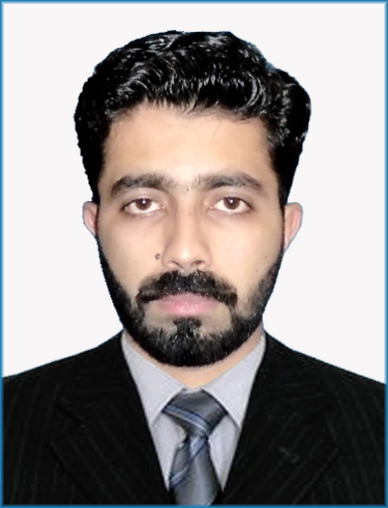

Saad Zahid
Skilled Chemist



Why Saad Zahid?
saadzahid790@gmail.com

 +92 345 9474790

Feb-15-1997
linkedin.com/in/saad-zahid-32042916a

Saad.zahid14

▪ Bachelor of Chemistry-Graduated from Pakistan’s one of best University & holding first position in Chemistry department with 3.81 CGP.
▪ Highly educated and skilled in research field of Chemistry. Performance-oriented professional with expertise in enhancing service levels and improving workflow processes.
▪ Solutions focused, proactive & research oriented with 4 years of strong Chemistry knowledge, extremely capable to manage challenging projects to promote growth through independent & group achievements. Possesses immaculate technical reporting skills & experience of Chemistry and Lab equipment control
▪ Effective team player having capability to ensure smooth execution of projects and timely delivery to meet objectives. Performance-oriented individual with strong problem-solving capabilities, adept to work & research in corporate environment with excellent communication and presentation skills.
▪ Process oriented individual willing to research in multi target based environment and poised to tackle multifaceted challenges of rapidly changing corporate setting. Seeking challenging position to utilize educational and technical skills and functional knowledge of Chemistry.

ACADEMIC RECORD

Degree | University/Board | Passing Year | Total Marks | Obtained Marks | Percentage/ CGP
BS (Chemistry) | University of Haripur | 2018 | 5800 | 4740 | 81.72/3.81
HSSC (Pre-Med) | BISE-ATD | 2014 | 1100 | 757 | 68.81
SSC (Science) | BISE-ATD | 2012 | 1050 | 859 | 81.80

TRAININGS/MAJOR SUBJECTS

▪ Attended four seminars related to the preparation of green synthesis of metallic nanoparticle.
▪ Attended 3-day conference on Emerging Trends in Biosciences and Biotechnology at Hazara University.
Basic chemistry | Biochemistry | Nano chemistry
Physical chemistry | Environmental chemistry | Physical chemistry (Lab)
Organic chemistry | Polymer chemistry | Organic chemistry (Lab)
Inorganic chemistry | Photo chemistry | Inorganic chemistry (Lab)
Analytical chemistry | Radiation chemistry | Biochemistry (Lab)

CORE STRENGTHS & ENABLING SKILLS

▪ UV-visible Technique
▪ SEM Technique
▪ XRD Analysis
▪ Refractometry Technique
▪ Endnote x7 Software
▪ Corel Draw Software

▪ TEM Technique ▪ Titration Technique
▪ EDX Technique

▪ FTIR Analysis
▪ Rotary Technique
▪ Analytical & Communication Skills

PROFESSIONAL EXPERIENCE

▪ One-year experience in AIMS International School and Colleges (1/9/2016 to 2/8/2017).
▪ One-year experience in Concept academy as a coordinator.
▪ 1-week training programme on public awareness about Thalassemia.
▪ 3-day Conference on Emerging Trends in Bioinformatics and Biosciences.

OTHER QUALIFICATION

 ▪ Research work: Biosynthesis, Characterization and antibacterial activity of Metallic Nanoparticles.

