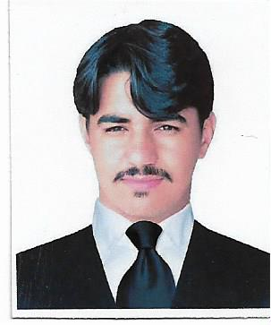
Curriculum Vitae

Name: Muzamil Jehangir
Personal Data:
Father Name: Jehangir Khan
Religion: Islam
Nationality: Pakistani
Marital Status: Single
Domicile: Karak
Date of birth: 13-May-1992
CNIC number: 14203-6645972-1
Cell No: 0331-8061766 E-mail: muzamiljehangir@yahoo.com

Permanent address:
Village, P/O and Tehsil Takht-e-Nasrati Disst Karak (KPK) Objectives: To develop my career with strong communication skills in a progressive, challenging and result-oriented organization in Chemical processing sector through professional excellence. Education: B.S Chemical Engineering: BUITEMS Quetta
2010-2014 CGPA 3.10/4.00

HSSC Pre Engg: Hira Model School & College Takht-e-Nasrati (Karak)

2008-2010 786/1100 (71.45 %)

SSC Science: Hira Model School & College Takht-e-Nasrati (Karak)

2008 700/900 (77.77 %)

Professional Experience:
- One year working Experience at OGDCL (Oil and Gas Development Company Limited)
- Worked at Installing and Commissioning of OGDCL Nashpa Oil and Gas Processing and LPG Recovery Plant at Disst Karak KPK.
- Attend Commissioning of Different Process Equipments (Compressors, Pumps, Heat Exchangers, Distillation Columns, Vessels, Cooling Towers etc).
- Attend 15 Days Shutdown Job at OGDCL Nashpa Oil Field.
- One year Working Experience at Frontier Group of Industries Peshawar
as a Quality Supervisor Junior.
- During Job Perform Different Quality Test’s of Raw Material and Final Product (Mesh sizing, Fibres screening, Density and viscosity) etc.

Computer Skills:
- MATLAB.
- Auto CAD.
- MS Office.
- Sufficient knowledge of computer hardware and windows installation.
- CAD CAM
- Hysis3.2

Projects:
- Production of Ethanol From Pine Cone

Languages:
- English Read, Write, Speak
- Urdu Read, Write, Speak
- Pashto Read, Write, Speak

References:
- Engr Aftab Alam (OGDCL) Incharge Process 03119279772
- Engr Fahad Shabir (OGDCL) Shift Incharge Process 03139775532

